UNITED STATES
SECURITIES AND EXCHANGE COMMISSION
Washington, D.C. 20549
__________________________________________
FORM 8-K
__________________________________________
CURRENT REPORT
Pursuant to Section 13 or 15(d)
of the Securities Exchange Act of 1934
Date of report (date of earliest event reported): July 27, 2026
__________________________________________
NOBLE CORPORATION plc
(Exact name of registrant as specified in its charter)
England and Wales |  |  |  |  |  | 001-41520 |  |  |  |  |  | 98-1644664
(State or other jurisdiction of incorporation) |  |  |  |  |  | (Commission file number) |  |  |  |  |  | (I.R.S. employer identification no.)
2101 City West Boulevard, |  |  | Suite 600, |  |  | Houston, |  |  | Texas |  |  | 77042
(Address of principal executive offices) |  |  |  |  |  |  |  |  |  |  |  | (Zip code)
Registrant’s telephone number, including area code: (281) 276-6100
__________________________________________
Check the appropriate box below if the Form 8-K filing is intended to simultaneously satisfy the filing obligation of the registrant under any of the following provisions
☐ |  |  | Written communications pursuant to Rule 425 under the Securities Act (17 CFR 230.425)
☐ |  |  | Soliciting material pursuant to Rule 14a-12 under the Exchange Act (17 CFR 240.14a-12)
☐ |  |  | Pre-commencement communications pursuant to Rule 14d-2(b) under the Exchange Act (17 CFR 240.14d-2(b))
☐ |  |  | Pre-commencement communications pursuant to Rule 13e-4(c) under the Exchange Act (17 CFR 240.13e-4(c))

Securities registered pursuant to Section 12(b) of the Act:
Title of each class |  |  | Trading Symbol(s) |  |  | Name of each exchange on which registered
A Ordinary Shares, par value $0.00001 per share |  |  | NE |  |  | New York Stock Exchange
Tranche 1 Warrants of Noble Corporation plc |  |  | NE WS |  |  | New York Stock Exchange
Tranche 2 Warrants of Noble Corporation plc |  |  | NE WSA |  |  | New York Stock Exchange
Indicate by check mark whether the registrant is an emerging growth company as defined in Rule 405 of the Securities Act of 1933 (§230.405 of this chapter) or Rule 12b-2 of the Securities Exchange Act of 1934 (§240.12b-2 of this chapter).
Emerging growth company ☐
If an emerging growth company, indicate by check mark if the registrant has elected not to use the extended transition period for complying with any new or revised financial accounting standards provided pursuant to Section 13(a) of the Exchange Act. ☐

Item 2.02. Results of Operations and Financial Condition.
On July 27, 2026, Noble Corporation plc (the “Company”) issued a press release announcing its condensed consolidated financial results for the quarter ended June 30, 2026. A copy of such press release is included as Exhibit 99.1 and will be published in the “Investors” section on the Company’s website at www.noblecorp.com.
Pursuant to the rules and regulations of the Securities and Exchange Commission, the press release is being furnished and shall not be deemed to be “filed” under the Securities Exchange Act of 1934.
Item 7.01. Regulation FD Disclosure.
On July 28, 2026, the President and Chief Executive Officer of Noble Corporation plc (NYSE: NE), Robert W. Eifler, together with other executive officers, plan to announce Noble Corporation plc's earnings for the quarter ended June 30, 2026, via teleconference, which will be open to the public and broadcast live over the internet. A copy of the slide presentation used in connection with the teleconference is attached as Exhibit 99.2 and is incorporated by reference into this item.
Pursuant to the rules and regulations of the Securities and Exchange Commission, the slide presentation is being furnished and shall not be deemed to be “filed” under the Securities Exchange Act of 1934.
Item 9.01. Financial Statements and Exhibits.
 |  |  |  |  |  | (d) Exhibits
EXHIBIT
NUMBER |  |  |  |  |  | DESCRIPTION
Exhibit 99.1 |  |  |  |  |  | Press Release issued by Noble Corporation plc dated July 27, 2026
Exhibit 99.2 |  |  |  |  |  | Noble Corporation plc Slide Presentation dated July 28, 2026
Exhibit 104 |  |  |  |  |  | Cover Page Interactive Data File – the cover page XBRL tags are embedded within the Inline XBRL document.
SIGNATURES
Pursuant to the requirements of the Securities Exchange Act of 1934, the Registrant has duly caused this report to be signed on its behalf by the undersigned hereunto duly authorized.
 |  |  |  |  |  |  |  |  |  |  |  |  |  |  | NOBLE CORPORATION plc
Date: |  |  | July 27, 2026 |  |  |  |  |  |  |  |  |  |  |  | By: |  |  |  |  |  | /s/ Robert W. Eifler
 |  |  |  |  |  |  |  |  |  |  |  |  |  |  |  |  |  |  |  |  | Robert W. Eifler
 |  |  |  |  |  |  |  |  |  |  |  |  |  |  |  |  |  |  |  |  | President and Chief Executive Officer

EXHIBIT 99.1

PRESS RELEASE |  |  |  |  |  | 
NOBLE CORPORATION PLC ANNOUNCES SECOND QUARTER 2026 RESULTS
•Approximately $200 million in new contract value since the April fleet status report, including a 6-well contract for the Noble Viking and a 3-well contract for the Noble Claus Bachmann; backlog stands at $6.8 billion.
•Successful refinancing of the legacy Diamond notes, simplifying the capital structure and unlocking $35 million in annual cash benefits (primarily interest and tax related).
•$0.50 per share cash dividend declared for Q3, maintaining consistent return of capital program.
•Q2 Net Loss of $37 million, Diluted Loss per Share of ($0.23), Adjusted Diluted Earnings per Share of $0.01, Adjusted EBITDA of $212 million, net cash provided by operating activities of $144 million, and Free Cash Flow of $(59) million.
•Full Year 2026 Guidance for Revenue and Adjusted EBITDA reduced; capital expenditures guidance maintained.
HOUSTON, TEXAS, July 27, 2026 - Noble Corporation plc (NYSE: NE, “Noble” or the “Company”) today reported second quarter 2026 results.
 |  |  |  |  |  | Three Months Ended
(in millions, except per share amounts) |  |  |  |  |  | June 30, 2026 |  |  |  |  |  | June 30, 2025 |  |  |  |  |  | March 31,  2026
Total Revenue |  |  |  |  |  | $ | 720 |  |  |  |  | $ | 849 |  |  |  |  | $ | 786
Contract Drilling Services Revenue |  |  |  |  |  | 679 |  |  |  |  |  | 812 |  |  |  |  |  | 743
Net Income (Loss) |  |  |  |  |  | (37) |  |  |  |  |  | 43 |  |  |  |  |  | 121
Adjusted EBITDA* |  |  |  |  |  | 212 |  |  |  |  |  | 282 |  |  |  |  |  | 277
Adjusted Net Income (Loss)* |  |  |  |  |  | 2 |  |  |  |  |  | 20 |  |  |  |  |  | 41
Basic Earnings (Loss) Per Share |  |  |  |  |  | (0.23) |  |  |  |  |  | 0.27 |  |  |  |  |  | 0.76
Diluted Earnings (Loss) Per Share |  |  |  |  |  | (0.23) |  |  |  |  |  | 0.27 |  |  |  |  |  | 0.75
Adjusted Diluted Earnings (Loss) Per Share* |  |  |  |  |  | 0.01 |  |  |  |  |  | 0.13 |  |  |  |  |  | 0.26
* A Non-GAAP supporting schedule is included with the statements and schedules in this press release.
Robert W. Eifler, President and Chief Executive Officer of Noble, stated, “Our second quarter was adversely impacted by $43 million due to the operational suspension of both of our rigs in Brazil, while operational and financial performance was otherwise strong across the board. Additionally, we completed a highly successful debt refinancing, which is expected to drive meaningful cash benefits going forward. The continued importance of offshore investment is supportive of strong rig demand, with increasing market tightness for high spec drillships driving leading edge dayrates into the mid $400,000s per day.”
Second Quarter Results
Contract drilling services revenue for the second quarter of 2026 totaled $679 million compared to $743 million in the prior quarter, with the sequential decrease driven primarily by the operational suspensions impacting the Noble Faye Kozack and Noble Courage in Brazil (comprising approximately $43 million), as well as the conclusion of
1
the Noble Globetrotter I’s contract in the Black Sea. Utilization of the 29 marketed rigs was 64% in the second quarter of 2026 compared to 68% in the prior quarter. Contract drilling services costs for the second quarter were $446 million, down from $450 million in the prior quarter. Net income decreased to a $37 million loss in the second quarter of 2026 compared to net income of $121 million in the prior quarter, and Adjusted EBITDA decreased to $212 million in the second quarter of 2026, down from $277 million in the prior quarter. Net cash provided by operating activities in the second quarter of 2026 was $144 million, capital expenditures were $205 million, and free cash flow (non-GAAP) was $(59) million.
Balance Sheet & Capital Allocation
The Company's balance sheet as of June 30, 2026, reflected total debt principal value of $1.9 billion and cash (and cash equivalents) of $456 million. In June, the Company refinanced $800 million of existing bonds with a new offering of 6.250% senior unsecured notes due 2034. Second quarter results include an $18 million loss on debt extinguishment. The Company completed the lease buy-out regarding the third (of four total) Blackships BOP systems for $18 million during the second quarter. The buy-out of the last remaining BOP system is expected to occur in the fourth quarter of 2026 for $18 million. Additionally, the idle semisubmersible Ocean Apex was sold for scrapping in July, with net sale proceeds of approximately $5 million corresponding with a $42 million impairment taken during the second quarter.
On July 27, 2026, Noble’s Board of Directors approved an interim quarterly cash dividend on our ordinary shares of $0.50 per share for the third quarter of 2026. The $0.50 per share dividend is expected to be paid on September 24, 2026, to shareholders of record at close of business on September 3, 2026. Future quarterly dividends and other shareholder returns will be subject to, amongst other things, approval by the Board of Directors.
Operating Highlights and Backlog
Noble's fleet of 24 marketed floaters was 61% contracted during the second quarter compared with 68% in the prior quarter. Recent contract awards since last quarter have added approximately 16 months of new floater backlog, with leading edge dayrates for Tier-1 drillships increasing to the mid $400,000s. Utilization of Noble's 5 marketed ultra harsh jackups was 80% in the second quarter versus 66% during the prior quarter.
Subsequent to last quarter’s earnings press release, new contracts with a total contract value of approximately $200 million include the following:
•Noble Viking was awarded a six-well contract in Asia Pacific scheduled to commence in early 2028 with estimated duration of approximately 300 days.
•Noble Claus Bachmann was awarded a 3-well contract with bp in the UK North Sea. The contract is expected to commence in March 2027 with estimated duration of 150-210 days at a dayrate of $320,000 per day, plus a $5 million mobilization fee. The rig’s 3-year campaign with Aker BP is now scheduled to commence in direct continuation of the new bp contract.
Backlog as of July 27, 2026, stands at $6.8 billion. Backlog excludes mobilization and demobilization revenue.
Outlook
For the full year 2026, Revenue guidance is reduced to $2,800-$2,900 million (versus $2,800-$3,000 million previously) and Adjusted EBITDA guidance is reduced to $850-$925 million (versus $940-$1,020 million previously). Guidance for capital expenditures is unchanged at $615-$665 million.
Commenting on Noble’s outlook, Mr. Eifler stated, “Revised guidance primarily reflects reduced revenues for our two rigs operating in Brazil, as well as re-sequenced backlog in the second half of the year for the Noble Viking and Noble Innovator/Noble Intrepid. Despite these near-term revenue headwinds, the market outlook continues to look promising in 2027 and beyond for both deepwater and harsh environment rigs, as demonstrated by recent contract fixtures at increasing dayrates.”
Due to the forward-looking nature of Adjusted EBITDA and Capital Expenditures (net of reimbursements), management cannot reliably predict certain of the necessary components of the most directly comparable forward-looking GAAP measure, net income and capital expenditures, respectively. Accordingly, the Company is unable to present a quantitative reconciliation of such forward-looking non-GAAP financial measure to the most directly comparable forward-looking GAAP financial measure without unreasonable effort. The unavailable information could have a significant effect on Noble’s full year 2026 GAAP financial results.
2
Conference Call
Noble will host a conference call related to its second quarter 2026 results on Tuesday, July 28, 2026, at 8:00 a.m. U.S. Central Time. Interested parties may dial +1 833-461-5787 and refer to conference ID 351391458 approximately 15 minutes prior to the scheduled start time. Additionally, a live webcast link will be available on the Investor Relations section of the Company’s website. A webcast replay will be accessible for a limited time following the call.
Contact Noble Corporation plc
Ian Macpherson
Vice President - Investor Relations
+1 713-239-6019
imacpherson@noblecorp.com
About Noble Corporation plc
Noble is a leading offshore drilling contractor for the oil and gas industry. The Company owns and operates one of the most modern, versatile, and technically advanced fleets in the offshore drilling industry. Noble and its predecessors have been engaged in the contract drilling of oil and gas wells since 1921. Noble performs, through its subsidiaries, contract drilling services with a fleet of offshore drilling units focused largely on ultra-deepwater and high specification jackup drilling opportunities in both established and emerging regions worldwide. Additional information on Noble is available at www.noblecorp.com.
Forward-looking Statements
This communication includes “forward-looking statements” within the meaning of Section 27A of the Securities Act and Section 21E of the Exchange Act, as amended. All statements other than statements of historical facts included in this communication are forward looking statements, including, but not limited to, those regarding future guidance, including revenue, earnings and earnings per share, EBITDA and adjusted EBITDA, margins, leverage, operating results, project status, expenses, tax rates and deferred taxes, future cash benefit expectations, the offshore drilling market and demand fundamentals, costs, amount, effect or timing of cost savings, debt, the benefits or results of asset acquisitions and dispositions, cash flows and free cash flow expectations, capital expenditures and capital allocations expectations, including planned dividends and share repurchases, backlog, including projections for the achievement of revenue associated with performance, rig demand, contract awards and expected future contracts, options or extensions on existing contracts, anticipated contract start dates, major project schedules, dayrates and duration, customer actions, needs and the general customer landscape, operational suspensions, projections, strategies and objectives of management for current or future operations and business, any asset sales or the retirement of rigs, access to capital, fleet condition, utilization and strategy, timing and amount of insurance recoveries, current or future market outlook and current or future economic trends or events and their impact on the Company, 2026 financial guidance and any statements or descriptions of assumptions underlying any of the above. Forward-looking statements involve risks, uncertainties and assumptions, and actual results may differ materially from any future results expressed or implied by such forward-looking statements. When used in this communication, or in the documents incorporated by reference, the words “guidance,” “anticipate,” “aim,” “believe,” “continue,” “could,” “estimate,” “expect,” “future,” “goal,” “intend,” “likely,” “likelihood,” “may,” “might,” “on track,” “outlook,” “plan,” “possible,” “potential,” “predict,” “project,” “should,” “schedule,” “would,” “achieve,” “shall,” “seek,” “strategy,” “target,” “will” and similar expressions are intended to be among the statements that identify forward looking statements. Although we believe that the expectations reflected in such forward-looking statements are reasonable, we cannot assure you that such expectations will prove to be correct. These forward-looking statements speak only as of the date of this communication and we undertake no obligation to revise or update any forward-looking statement for any reason, except as required by law. Actual results may differ materially from any future results expressed or implied by such forward-looking statements and the expectations expressed in forward-looking statements are subject to a number of risks, uncertainties and assumptions which could affect our business, operating results, and financial condition and include, but are not limited to, market conditions and changes in customer demand, the level of activity in the oil and gas industry and the offshore contract drilling industry, current and future prices of oil and gas, customer actions and the general customer landscape, new or substitute contracts, awards and expected future contracts, contract duration, renewal, terminations, and repricing, dayrates and contract duration, operational suspensions, realization of our current backlog of contract drilling revenue, operating hazards, natural disasters, seasonal weather events and related damages or liabilities, acts of war, geopolitical conflicts, including the conflict involving Iran and related geopolitical instability in the Middle East, and their impact on commodity prices, global energy markets and regional and global shipping flows, risks relating to operations in international locations, upgrades, refurbishment, operation, and maintenance of our
3
rigs and related operational interruptions and delays, sales of drilling units, supplier capacity constraints or shortages, nonperformance by third-parties, suppliers and subcontractors, regulatory changes, the impact of governmental laws and regulations on our costs and the offshore drilling industry, potential impacts, liabilities and costs from pending or potential investigations, claims and tax or other disputes, and other factors, including those detailed in Noble’s most recent Annual Report on Form 10-K, Quarterly Reports on Form 10-Q and other filings with the U.S. Securities and Exchange Commission. We cannot control such risk factors and other uncertainties, and in many cases, we cannot predict the risks and uncertainties that could cause our actual results to differ materially from those indicated by the forward-looking statements. You should consider these risks and uncertainties when you are evaluating us. With respect to our capital allocation policy, distributions to shareholders in the form of either dividends or share buybacks are subject to the Board of Directors’ assessment of factors such as business development, growth strategy, current leverage and financing needs. There can be no assurance that a dividend or buyback program will be declared or continued.
Contract Backlog
The duration and timing (including both starting and ending dates) of the customer contracts are estimates only, and customer contracts are subject to cancellation, suspension, delays for a variety of reasons, and for certain customers, reallocation of term among contracted rigs, including some beyond Noble’s control. The contract backlog represents the maximum contract drilling revenues that can be earned when only considering the contractual operating dayrate in effect during the firm contract period. The actual average dayrate will depend upon a number of factors (e.g., rig downtime, suspension of operations, etc.) including some beyond Noble’s control. The dayrates do not include revenue for mobilizations, demobilizations, upgrades, contract preparation, shipyards, or recharges, unless specifically otherwise stated. Dayrates may include revenue associated with performance including, for example, approximately 40% assumed performance revenue realized on a combined basis under certain long-term contracts with Shell (US) and TotalEnergies (Suriname). The outcome of discussions regarding proposed administrative solutions following the operational suspension of the Noble Courage and Noble Faye Kozack remain uncertain and actual revenues earned by the rigs may differ from disclosed backlog.

4
NOBLE CORPORATION plc AND SUBSIDIARIES
CONDENSED CONSOLIDATED STATEMENTS OF OPERATIONS
(In thousands, except per share amounts)
 |  |  |  |  |  | Three Months Ended June 30, |  |  |  |  |  |  |  |  |  |  |  | Six Months Ended June 30,
 |  |  |  |  |  | 2026 |  |  |  |  |  | 2025 |  |  |  |  |  | 2026 |  |  |  |  |  | 2025
Operating revenues
Contract drilling services |  |  |  |  |  | $ | 679,444 |  |  |  |  | $ | 812,077 |  |  |  |  | $ | 1,421,997 |  |  |  |  | $ | 1,644,505
Reimbursables and other |  |  |  |  |  | 40,244 |  |  |  |  |  | 36,575 |  |  |  |  |  | 83,381 |  |  |  |  |  | 78,634
 |  |  |  |  |  | 719,688 |  |  |  |  |  | 848,652 |  |  |  |  |  | 1,505,378 |  |  |  |  |  | 1,723,139
Operating costs and expenses
Contract drilling services |  |  |  |  |  | 446,309 |  |  |  |  |  | 502,427 |  |  |  |  |  | 896,434 |  |  |  |  |  | 964,526
Reimbursables |  |  |  |  |  | 34,108 |  |  |  |  |  | 28,360 |  |  |  |  |  | 64,220 |  |  |  |  |  | 60,144
Depreciation and amortization |  |  |  |  |  | 139,582 |  |  |  |  |  | 147,085 |  |  |  |  |  | 276,922 |  |  |  |  |  | 290,222
General and administrative |  |  |  |  |  | 26,944 |  |  |  |  |  | 34,976 |  |  |  |  |  | 56,992 |  |  |  |  |  | 70,184
Merger and integration costs |  |  |  |  |  | — |  |  |  |  |  | 5,302 |  |  |  |  |  | 2,615 |  |  |  |  |  | 20,222
(Gain) loss on sale of operating assets, net |  |  |  |  |  | — |  |  |  |  |  | (4,751) |  |  |  |  |  | (89,858) |  |  |  |  |  | (4,751)
Loss on Impairment |  |  |  |  |  | 42,270 |  |  |  |  |  | — |  |  |  |  |  | 42,270 |  |  |  |  |  | —
 |  |  |  |  |  | 689,213 |  |  |  |  |  | 713,399 |  |  |  |  |  | 1,249,595 |  |  |  |  |  | 1,400,547
Operating income (loss) |  |  |  |  |  | 30,475 |  |  |  |  |  | 135,253 |  |  |  |  |  | 255,783 |  |  |  |  |  | 322,592
Other income (expense)
Interest expense, net of amounts capitalized |  |  |  |  |  | (36,203) |  |  |  |  |  | (39,997) |  |  |  |  |  | (76,762) |  |  |  |  |  | (80,464)
Gain (loss) on extinguishment of debt, net |  |  |  |  |  | (18,329) |  |  |  |  |  | — |  |  |  |  |  | (17,603) |  |  |  |  |  | —
Interest income and other, net |  |  |  |  |  | 3,664 |  |  |  |  |  | 4,712 |  |  |  |  |  | 11,861 |  |  |  |  |  | 6,549
Income (loss) before income taxes |  |  |  |  |  | (20,393) |  |  |  |  |  | 99,968 |  |  |  |  |  | 173,279 |  |  |  |  |  | 248,677
Income tax benefit (provision) |  |  |  |  |  | (16,291) |  |  |  |  |  | (57,096) |  |  |  |  |  | (89,238) |  |  |  |  |  | (97,502)
Net income (loss) |  |  |  |  |  | $ | (36,684) |  |  |  |  | $ | 42,872 |  |  |  |  | $ | 84,041 |  |  |  |  | $ | 151,175
Basic earnings (loss) per share |  |  |  |  |  | $ | (0.23) |  |  |  |  | $ | 0.27 |  |  |  |  | $ | 0.53 |  |  |  |  | $ | 0.95
Diluted earnings (loss) per share |  |  |  |  |  | $ | (0.23) |  |  |  |  | $ | 0.27 |  |  |  |  | $ | 0.52 |  |  |  |  | $ | 0.93

5
NOBLE CORPORATION plc AND SUBSIDIARIES
CONDENSED CONSOLIDATED BALANCE SHEETS
(In thousands)
(Unaudited)
 |  |  |  |  |  | June 30, 2026 |  |  |  |  |  | December 31, 2025
ASSETS
Current assets
Cash and cash equivalents |  |  |  |  |  | $ | 456,208 |  |  |  |  | $ | 471,399
Accounts receivable, net |  |  |  |  |  | 547,814 |  |  |  |  |  | 589,597
Prepaid expenses and other current assets |  |  |  |  |  | 171,201 |  |  |  |  |  | 211,286
Total current assets |  |  |  |  |  | 1,175,223 |  |  |  |  |  | 1,272,282
Property and equipment, at cost |  |  |  |  |  | 6,958,223 |  |  |  |  |  | 6,639,045
Accumulated depreciation |  |  |  |  |  | (1,504,613) |  |  |  |  |  | (1,236,222)
Property and equipment, net |  |  |  |  |  | 5,453,610 |  |  |  |  |  | 5,402,823
Other assets |  |  |  |  |  | 610,273 |  |  |  |  |  | 854,662
Total assets |  |  |  |  |  | $ | 7,239,106 |  |  |  |  | $ | 7,529,767
LIABILITIES AND EQUITY
Current liabilities
Accounts payable |  |  |  |  |  | $ | 323,958 |  |  |  |  | $ | 298,751
Accrued payroll and related costs |  |  |  |  |  | 52,020 |  |  |  |  |  | 81,754
Other current liabilities |  |  |  |  |  | 237,838 |  |  |  |  |  | 379,224
Total current liabilities |  |  |  |  |  | 613,816 |  |  |  |  |  | 759,729
Long-term debt |  |  |  |  |  | 1,888,430 |  |  |  |  |  | 1,975,791
Other liabilities |  |  |  |  |  | 252,918 |  |  |  |  |  | 245,397
Total liabilities |  |  |  |  |  | 2,755,164 |  |  |  |  |  | 2,980,917
Commitments and contingencies
Total shareholders’ equity |  |  |  |  |  | 4,483,942 |  |  |  |  |  | 4,548,850
Total liabilities and equity |  |  |  |  |  | $ | 7,239,106 |  |  |  |  | $ | 7,529,767

6
NOBLE CORPORATION plc AND SUBSIDIARIES
CONDENSED CONSOLIDATED STATEMENTS OF CASH FLOWS
(In thousands)
(Unaudited)
 |  |  |  |  |  | Six Months Ended June 30,
 |  |  |  |  |  | 2026 |  |  |  |  |  | 2025
Cash flows from operating activities
Net income (loss) |  |  |  |  |  | $ | 84,041 |  |  |  |  | $ | 151,175
Adjustments to reconcile net income (loss) to net cash flow from operating activities:
Depreciation and amortization |  |  |  |  |  | 276,922 |  |  |  |  |  | 290,222
Amortization of intangible assets and contract liabilities, net |  |  |  |  |  | — |  |  |  |  |  | (8,366)
(Gain) loss on extinguishment of debt, net |  |  |  |  |  | 17,603 |  |  |  |  |  | —
(Gain) loss on sale of operating assets, net |  |  |  |  |  | (89,858) |  |  |  |  |  | (4,751)
Loss on impairment |  |  |  |  |  | 42,270 |  |  |  |  |  | —
Other operating activities |  |  |  |  |  | 86,471 |  |  |  |  |  | 59,137
Net cash provided by (used in) operating activities |  |  |  |  |  | 417,449 |  |  |  |  |  | 487,417
Cash flows from investing activities
Capital expenditures |  |  |  |  |  | (308,383) |  |  |  |  |  | (230,117)
Proceeds from insurance claims |  |  |  |  |  | 1,584 |  |  |  |  |  | 22,201
Proceeds from disposal of assets, net |  |  |  |  |  | 206,400 |  |  |  |  |  | 16,190
Net cash provided by (used in) investing activities |  |  |  |  |  | (100,399) |  |  |  |  |  | (191,726)
Cash flows from financing activities
Issuance of debt |  |  |  |  |  | 800,000 |  |  |  |  |  | —
Repayments of debt |  |  |  |  |  | (850,000) |  |  |  |  |  | —
Debt extinguishment costs |  |  |  |  |  | (40,727) |  |  |  |  |  | —
Debt issuance costs |  |  |  |  |  | (17,418) |  |  |  |  |  | —
Warrants exercised |  |  |  |  |  | 3,053 |  |  |  |  |  | 38
Share repurchases |  |  |  |  |  | — |  |  |  |  |  | (20,000)
Dividend payments |  |  |  |  |  | (163,220) |  |  |  |  |  | (160,921)
Withholding tax related to employee stock transactions |  |  |  |  |  | (9,720) |  |  |  |  |  | (9,447)
Finance lease payments |  |  |  |  |  | (62,526) |  |  |  |  |  | (12,187)
Net cash provided by (used in) financing activities |  |  |  |  |  | (340,558) |  |  |  |  |  | (202,517)
Net increase (decrease) in cash, cash equivalents and restricted cash |  |  |  |  |  | (23,508) |  |  |  |  |  | 93,174
Cash, cash equivalents and restricted cash, beginning of period |  |  |  |  |  | 479,960 |  |  |  |  |  | 252,279
Cash, cash equivalents and restricted cash, end of period |  |  |  |  |  | $ | 456,452 |  |  |  |  | $ | 345,453

7
NOBLE CORPORATION plc AND SUBSIDIARIES
OPERATIONAL INFORMATION
(Unaudited)
 |  |  |  |  |  | Average Rig Utilization (1)
 |  |  |  |  |  | Three Months Ended |  |  |  |  |  | Three Months Ended |  |  |  |  |  | Three Months Ended
 |  |  |  |  |  | June 30, 2026 |  |  |  |  |  | March 31, 2026 |  |  |  |  |  | June 30, 2025
Floaters |  |  |  |  |  | 59 |  | % |  |  |  | 65 |  | % |  |  |  | 70 |  | %
Jackups |  |  |  |  |  | 83 |  | % |  |  |  | 78 |  | % |  |  |  | 61 |  | %
Total |  |  |  |  |  | 65 |  | % |  |  |  | 69 |  | % |  |  |  | 67 |  | %
 |  |  |  |  |  | Operating Days
 |  |  |  |  |  | Three Months Ended |  |  |  |  |  | Three Months Ended |  |  |  |  |  | Three Months Ended
 |  |  |  |  |  | June 30, 2026 |  |  |  |  |  | March 31, 2026 |  |  |  |  |  | June 30, 2025
Floaters |  |  |  |  |  | 1,335 |  |  |  |  |  | 1,470 |  |  |  |  |  | 1,705
Jackups |  |  |  |  |  | 651 |  |  |  |  |  | 660 |  |  |  |  |  | 724
Total |  |  |  |  |  | 1,986 |  |  |  |  |  | 2,130 |  |  |  |  |  | 2,429
 |  |  |  |  |  | Average Dayrates
 |  |  |  |  |  | Three Months Ended |  |  |  |  |  | Three Months Ended |  |  |  |  |  | Three Months Ended
 |  |  |  |  |  | June 30, 2026 |  |  |  |  |  | March 31, 2026 |  |  |  |  |  | June 30, 2025
Floaters |  |  |  |  |  | $ | 412,650 |  |  |  |  | $ | 422,076 |  |  |  |  | $ | 400,802
Jackups |  |  |  |  |  | 197,380 |  |  |  |  |  | 184,807 |  |  |  |  |  | 176,503
Total |  |  |  |  |  | $ | 342,080 |  |  |  |  | $ | 348,554 |  |  |  |  | $ | 333,960
(1) Average Rig Utilization statistics include all marketed and cold stacked rigs.

8
NOBLE CORPORATION plc AND SUBSIDIARIES
CALCULATION OF BASIC AND DILUTED EARNINGS/(LOSS) PER SHARE
(In thousands, except per share amounts)
(Unaudited)

The following tables presents the computation of basic and diluted earnings (loss) per share:
 |  |  |  |  |  | Three Months Ended  June 30, |  |  |  |  |  |  |  |  |  |  |  | Six Months Ended  June 30,
 |  |  |  |  |  | 2026 |  |  |  |  |  | 2025 |  |  |  |  |  | 2026 |  |  |  |  |  | 2025
Numerator:
Net income (loss) |  |  |  |  |  | $ | (36,684) |  |  |  |  | $ | 42,872 |  |  |  |  | $ | 84,041 |  |  |  |  | $ | 151,175
Denominator:
Weighted average shares outstanding - basic |  |  |  |  |  | 159,573 |  |  |  |  |  | 158,798 |  |  |  |  |  | 159,397 |  |  |  |  |  | 158,901
Dilutive effect of share-based awards |  |  |  |  |  | — |  |  |  |  |  | 2,084 |  |  |  |  |  | 1,269 |  |  |  |  |  | 2,084
Dilutive effect of warrants |  |  |  |  |  | — |  |  |  |  |  | 646 |  |  |  |  |  | 1,200 |  |  |  |  |  | 787
Weighted average shares outstanding - diluted |  |  |  |  |  | 159,573 |  |  |  |  |  | 161,528 |  |  |  |  |  | 161,866 |  |  |  |  |  | 161,772
Earnings (loss) per share data:
Basic |  |  |  |  |  | $ | (0.23) |  |  |  |  | $ | 0.27 |  |  |  |  | $ | 0.53 |  |  |  |  | $ | 0.95
Diluted |  |  |  |  |  | $ | (0.23) |  |  |  |  | $ | 0.27 |  |  |  |  | $ | 0.52 |  |  |  |  | $ | 0.93

9
NOBLE CORPORATION plc AND SUBSIDIARIES
NON-GAAP MEASURES AND RECONCILIATION
Certain non-GAAP measures and corresponding reconciliations to GAAP financial measures for the Company have been provided for meaningful comparisons between current results and prior operating periods. Generally, a non-GAAP financial measure is a numerical measure of a company’s performance, financial position, or cash flows that excludes or includes amounts that are not normally included or excluded in the most directly comparable measure calculated and presented in accordance with generally accepted accounting principles.
The Company defines “Adjusted EBITDA” as net income (loss) adjusted for interest expense, net of amounts capitalized; interest income and other, net; income tax benefit (provision); and depreciation and amortization expense, as well as, if applicable, gain (loss) on extinguishment of debt, net; losses on economic impairments; amortization of intangible assets and contract liabilities, net; restructuring and similar charges; costs related to mergers and integrations; and certain other infrequent operational events. We believe that the Adjusted EBITDA measure provides greater transparency of our core operating performance. We prepare Adjusted Net Income (Loss) by eliminating from Net Income (Loss) the impact of a number of non-recurring items we do not consider indicative of our on-going performance. We prepare Adjusted Diluted Earnings (Loss) per Share by eliminating from Diluted Earnings (Loss) per Share the impact of a number of non-recurring items we do not consider indicative of our on-going performance. Similar to Adjusted EBITDA, we believe these measures help identify underlying trends that could otherwise be masked by the effect of the non-recurring items we exclude in the measure.
The Company also discloses free cash flow as a non-GAAP liquidity measure. Free cash flow is calculated as Net cash provided by (used in) operating activities less cash paid for capital expenditures. We believe Free Cash Flow is useful to investors because it measures our ability to generate or use cash. Once business needs and obligations are met, this cash can be used to reinvest in the company for future growth or to return to shareholders through dividend payments or share repurchases. We may have certain obligations such as non-discretionary debt service that are not deducted from the measure. Such business needs, obligations, and other non-discretionary expenditures that are not deducted from Free Cash Flow would reduce cash available for other uses including return of capital.
We believe that these non-GAAP financial measures provide useful information about our financial performance, enhance the overall understanding of our past performance and future prospects, and allow for greater transparency with respect to key metrics used by our management team for financial and operational decision-making. We are presenting these non-GAAP financial measures to assist investors in seeing our financial performance through the eyes of management, and because we believe that these measures provide an additional tool for investors to use in comparing our core financial performance over multiple periods with other companies in our industry.
These non-GAAP adjusted measures should be considered in addition to, and not as a substitute for, or superior to, contract drilling revenue, contract drilling costs, contract drilling margin, average daily revenue, operating income, cash flows from operations, or other measures of financial performance prepared in accordance with GAAP. Please see the following non-GAAP Financial Measures and Reconciliations for a complete description of the adjustments.

10
NOBLE CORPORATION plc AND SUBSIDIARIES
NON-GAAP MEASURES AND RECONCILIATION
(In thousands, except per share amounts)
(Unaudited)
Reconciliation of Adjusted EBITDA
 |  |  |  |  |  | Three Months Ended June 30, |  |  |  |  |  |  |  |  |  |  |  | Three Months Ended
 |  |  |  |  |  | 2026 |  |  |  |  |  | 2025 |  |  |  |  |  | March 31, 2026
Net income (loss) |  |  |  |  |  | $ | (36,684) |  |  |  |  | $ | 42,872 |  |  |  |  | $ | 120,725
Income tax (benefit) provision |  |  |  |  |  | 16,291 |  |  |  |  |  | 57,096 |  |  |  |  |  | 72,947
Interest expense, net of amounts capitalized |  |  |  |  |  | 36,203 |  |  |  |  |  | 39,997 |  |  |  |  |  | 40,559
Interest income and other, net |  |  |  |  |  | (3,664) |  |  |  |  |  | (4,712) |  |  |  |  |  | (8,197)
Depreciation and amortization |  |  |  |  |  | 139,582 |  |  |  |  |  | 147,085 |  |  |  |  |  | 137,340
Amortization of intangible assets and contract liabilities, net |  |  |  |  |  | — |  |  |  |  |  | (915) |  |  |  |  |  | —
Costs incurred in connection with contract termination |  |  |  |  |  | — |  |  |  |  |  | — |  |  |  |  |  | 2,000
(Gain) loss on extinguishment of debt, net |  |  |  |  |  | 18,329 |  |  |  |  |  | — |  |  |  |  |  | (726)
Merger and integration costs |  |  |  |  |  | — |  |  |  |  |  | 5,302 |  |  |  |  |  | 2,615
(Gain) loss on sale of operating assets, net |  |  |  |  |  | — |  |  |  |  |  | (4,751) |  |  |  |  |  | (89,858)
Loss on impairment |  |  |  |  |  | 42,270 |  |  |  |  |  | — |  |  |  |  |  | —
Adjusted EBITDA |  |  |  |  |  | $ | 212,327 |  |  |  |  | $ | 281,974 |  |  |  |  | $ | 277,405
Reconciliation of Adjusted Income Tax Benefit (Provision)
 |  |  |  |  |  | Three Months Ended June 30, |  |  |  |  |  |  |  |  |  |  |  | Three Months Ended
 |  |  |  |  |  | 2026 |  |  |  |  |  | 2025 |  |  |  |  |  | March 31, 2026
Income tax benefit (provision) |  |  |  |  |  | $ | (16,291) |  |  |  |  | $ | (57,096) |  |  |  |  | $ | (72,947)
Adjustments
Costs incurred in connection with contract termination |  |  |  |  |  | — |  |  |  |  |  | — |  |  |  |  |  | (420)
Gain (loss) on sale of operating assets, net |  |  |  |  |  | — |  |  |  |  |  | — |  |  |  |  |  | 23,504
Discrete tax items |  |  |  |  |  | (23,039) |  |  |  |  |  | (22,129) |  |  |  |  |  | (16,621)
Total adjustments |  |  |  |  |  | (23,039) |  |  |  |  |  | (22,129) |  |  |  |  |  | 6,463
Adjusted income tax benefit (provision) |  |  |  |  |  | $ | (39,330) |  |  |  |  | $ | (79,225) |  |  |  |  | $ | (66,484)
11
NOBLE CORPORATION plc AND SUBSIDIARIES
NON-GAAP MEASURES AND RECONCILIATION
(In thousands, except per share amounts)
(Unaudited)
Reconciliation of Adjusted Net Income (Loss)
 |  |  |  |  |  | Three Months Ended June 30, |  |  |  |  |  |  |  |  |  |  |  | Three Months Ended
 |  |  |  |  |  | 2026 |  |  |  |  |  | 2025 |  |  |  |  |  | March 31, 2026
Net income (loss) |  |  |  |  |  | $ | (36,684) |  |  |  |  | $ | 42,872 |  |  |  |  | $ | 120,725
Adjustments
Amortization of intangible assets and contract liabilities, net |  |  |  |  |  | — |  |  |  |  |  | (915) |  |  |  |  |  | —
Joint taxation scheme compensation |  |  |  |  |  | 1,093 |  |  |  |  |  | — |  |  |  |  |  | —
Merger and integration costs |  |  |  |  |  | — |  |  |  |  |  | 5,302 |  |  |  |  |  | 2,615
(Gain) loss on sale of operating assets, net |  |  |  |  |  | — |  |  |  |  |  | (4,751) |  |  |  |  |  | (66,354)
Loss on impairment |  |  |  |  |  | 42,270 |  |  |  |  |  | — |  |  |  |  |  | —
Costs incurred in connection with contract termination, net |  |  |  |  |  | — |  |  |  |  |  | — |  |  |  |  |  | 1,580
(Gain) loss on extinguishment of debt, net |  |  |  |  |  | 18,329 |  |  |  |  |  | — |  |  |  |  |  | (726)
Discrete tax items |  |  |  |  |  | (23,039) |  |  |  |  |  | (22,129) |  |  |  |  |  | (16,621)
Total adjustments |  |  |  |  |  | 38,653 |  |  |  |  |  | (22,493) |  |  |  |  |  | (79,506)
Adjusted net income (loss) |  |  |  |  |  | $ | 1,969 |  |  |  |  | $ | 20,379 |  |  |  |  | $ | 41,219
Reconciliation of Adjusted Diluted EPS
 |  |  |  |  |  | Three Months Ended June 30, |  |  |  |  |  |  |  |  |  |  |  | Three Months Ended
 |  |  |  |  |  | 2026 |  |  |  |  |  | 2025 |  |  |  |  |  | March 31, 2026
Unadjusted diluted EPS |  |  |  |  |  | $ | (0.23) |  |  |  |  | $ | 0.27 |  |  |  |  | $ | 0.75
Adjustments
Amortization of intangible assets and contract liabilities, net |  |  |  |  |  | — |  |  |  |  |  | (0.01) |  |  |  |  |  | —
Joint taxation scheme compensation |  |  |  |  |  | 0.01 |  |  |  |  |  | — |  |  |  |  |  | —
Merger and integration costs |  |  |  |  |  | — |  |  |  |  |  | 0.03 |  |  |  |  |  | 0.02
(Gain) loss on sale of operating assets, net |  |  |  |  |  | — |  |  |  |  |  | (0.02) |  |  |  |  |  | (0.42)
Loss on impairment |  |  |  |  |  | 0.26 |  |  |  |  |  | — |  |  |  |  |  | —
Costs incurred in connection with contract termination, net |  |  |  |  |  | — |  |  |  |  |  | — |  |  |  |  |  | 0.01
(Gain) loss on extinguishment of debt, net |  |  |  |  |  | 0.11 |  |  |  |  |  | — |  |  |  |  |  | —
Discrete tax items |  |  |  |  |  | (0.14) |  |  |  |  |  | (0.14) |  |  |  |  |  | (0.10)
Total adjustments |  |  |  |  |  | 0.24 |  |  |  |  |  | (0.14) |  |  |  |  |  | (0.49)
Adjusted diluted EPS |  |  |  |  |  | $ | 0.01 |  |  |  |  | $ | 0.13 |  |  |  |  | $ | 0.26
Reconciliation of Free Cash Flow and Capital Expenditures, net of Proceeds from Insurance Claims
 |  |  |  |  |  | Three Months Ended June 30, |  |  |  |  |  |  |  |  |  |  |  | Three Months Ended
 |  |  |  |  |  | 2026 |  |  |  |  |  | 2025 |  |  |  |  |  | March 31, 2026
Net cash provided by (used in) operating activities |  |  |  |  |  | $ | 144,159 |  |  |  |  | $ | 216,357 |  |  |  |  | $ | 273,290
Capital expenditures |  |  |  |  |  | (204,530) |  |  |  |  |  | (116,581) |  |  |  |  |  | (103,853)
Proceeds from insurance claims |  |  |  |  |  | 1,584 |  |  |  |  |  | 6,810 |  |  |  |  |  | —
Free cash flow |  |  |  |  |  | $ | (58,787) |  |  |  |  | $ | 106,586 |  |  |  |  | $ | 169,437

12
Noble Corporation plc Second Quarter 2026 Earnings Conference Call July 28, 2026

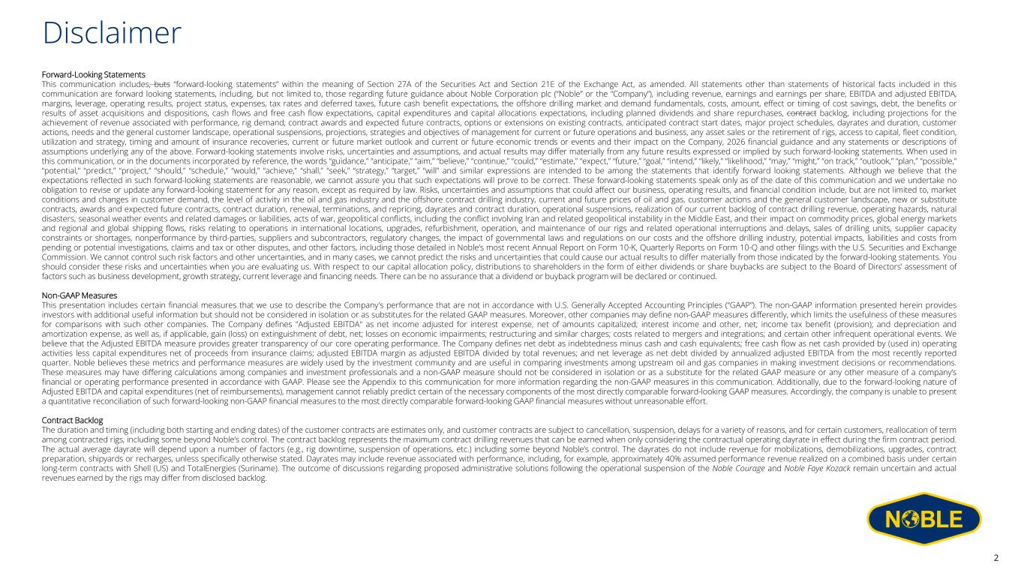
Disclaimer 2 Forward-Looking Statements This communication includes, buts “forward-looking statements” within the meaning of Section 27A of the Securities Act and Section 21E of the Exchange Act, as amended. All statements other than statements of historical facts included in this communication are forward looking statements, including, but not limited to, those regarding future guidance about Noble Corporation plc (“Noble” or the “Company”), including revenue, earnings and earnings per share, EBITDA and adjusted EBITDA, margins, leverage, operating results, project status, expenses, tax rates and deferred taxes, future cash benefit expectations, the offshore drilling market and demand fundamentals, costs, amount, effect or timing of cost savings, debt, the benefits or results of asset acquisitions and dispositions, cash flows and free cash flow expectations, capital expenditures and capital allocations expectations, including planned dividends and share repurchases, contract backlog, including projections for the achievement of revenue associated with performance, rig demand, contract awards and expected future contracts, options or extensions on existing contracts, anticipated contract start dates, major project schedules, dayrates and duration, customer actions, needs and the general customer landscape, operational suspensions, projections, strategies and objectives of management for current or future operations and business, any asset sales or the retirement of rigs, access to capital, fleet condition, utilization and strategy, timing and amount of insurance recoveries, current or future market outlook and current or future economic trends or events and their impact on the Company, 2026 financial guidance and any statements or descriptions of assumptions underlying any of the above. Forward-looking statements involve risks, uncertainties and assumptions, and actual results may differ materially from any future results expressed or implied by such forward-looking statements. When used in this communication, or in the documents incorporated by reference, the words “guidance,” “anticipate,” “aim,” “believe,” “continue,” “could,” “estimate,” “expect,” “future,” “goal,” “intend,” “likely,” “likelihood,” “may,” “might,” “on track,” “outlook,” “plan,” “possible,” “potential,” “predict,” “project,” “should,” “schedule,” “would,” “achieve,” “shall,” “seek,” “strategy,” “target,” “will” and similar expressions are intended to be among the statements that identify forward looking statements. Although we believe that the expectations reflected in such forward-looking statements are reasonable, we cannot assure you that such expectations will prove to be correct. These forward-looking statements speak only as of the date of this communication and we undertake no obligation to revise or update any forward-looking statement for any reason, except as required by law. Risks, uncertainties and assumptions that could affect our business, operating results, and financial condition include, but are not limited to, market conditions and changes in customer demand, the level of activity in the oil and gas industry and the offshore contract drilling industry, current and future prices of oil and gas, customer actions and the general customer landscape, new or substitute contracts, awards and expected future contracts, contract duration, renewal, terminations, and repricing, dayrates and contract duration, operational suspensions, realization of our current backlog of contract drilling revenue, operating hazards, natural disasters, seasonal weather events and related damages or liabilities, acts of war, geopolitical conflicts, including the conflict involving Iran and related geopolitical instability in the Middle East, and their impact on commodity prices, global energy markets and regional and global shipping flows, risks relating to operations in international locations, upgrades, refurbishment, operation, and maintenance of our rigs and related operational interruptions and delays, sales of drilling units, supplier capacity constraints or shortages, nonperformance by third-parties, suppliers and subcontractors, regulatory changes, the impact of governmental laws and regulations on our costs and the offshore drilling industry, potential impacts, liabilities and costs from pending or potential investigations, claims and tax or other disputes, and other factors, including those detailed in Noble’s most recent Annual Report on Form 10-K, Quarterly Reports on Form 10-Q and other filings with the U.S. Securities and Exchange Commission. We cannot control such risk factors and other uncertainties, and in many cases, we cannot predict the risks and uncertainties that could cause our actual results to differ materially from those indicated by the forward-looking statements. You should consider these risks and uncertainties when you are evaluating us. With respect to our capital allocation policy, distributions to shareholders in the form of either dividends or share buybacks are subject to the Board of Directors’ assessment of factors such as business development, growth strategy, current leverage and financing needs. There can be no assurance that a dividend or buyback program will be declared or continued. Non-GAAP Measures This presentation includes certain financial measures that we use to describe the Company's performance that are not in accordance with U.S. Generally Accepted Accounting Principles (“GAAP”). The non-GAAP information presented herein provides investors with additional useful information but should not be considered in isolation or as substitutes for the related GAAP measures. Moreover, other companies may define non-GAAP measures differently, which limits the usefulness of these measures for comparisons with such other companies. The Company defines "Adjusted EBITDA" as net income adjusted for interest expense, net of amounts capitalized; interest income and other, net; income tax benefit (provision); and depreciation and amortization expense, as well as, if applicable, gain (loss) on extinguishment of debt, net; losses on economic impairments; restructuring and similar charges; costs related to mergers and integrations; and certain other infrequent operational events. We believe that the Adjusted EBITDA measure provides greater transparency of our core operating performance. The Company defines net debt as indebtedness minus cash and cash equivalents; free cash flow as net cash provided by (used in) operating activities less capital expenditures net of proceeds from insurance claims; adjusted EBITDA margin as adjusted EBITDA divided by total revenues; and net leverage as net debt divided by annualized adjusted EBITDA from the most recently reported quarter. Noble believes these metrics and performance measures are widely used by the investment community and are useful in comparing investments among upstream oil and gas companies in making investment decisions or recommendations. These measures may have differing calculations among companies and investment professionals and a non-GAAP measure should not be considered in isolation or as a substitute for the related GAAP measure or any other measure of a company’s financial or operating performance presented in accordance with GAAP. Please see the Appendix to this communication for more information regarding the non-GAAP measures in this communication. Additionally, due to the forward-looking nature of Adjusted EBITDA and capital expenditures (net of reimbursements), management cannot reliably predict certain of the necessary components of the most directly comparable forward-looking GAAP measures. Accordingly, the company is unable to present a quantitative reconciliation of such forward-looking non-GAAP financial measures to the most directly comparable forward-looking GAAP financial measures without unreasonable effort. Contract Backlog The duration and timing (including both starting and ending dates) of the customer contracts are estimates only, and customer contracts are subject to cancellation, suspension, delays for a variety of reasons, and for certain customers, reallocation of term among contracted rigs, including some beyond Noble’s control. The contract backlog represents the maximum contract drilling revenues that can be earned when only considering the contractual operating dayrate in effect during the firm contract period. The actual average dayrate will depend upon a number of factors (e.g., rig downtime, suspension of operations, etc.) including some beyond Noble’s control. The dayrates do not include revenue for mobilizations, demobilizations, upgrades, contract preparation, shipyards or recharges, unless specifically otherwise stated. Dayrates may include revenue associated with performance, including, for example, approximately 40% assumed performance revenue realized on a combined basis under certain long-term contracts with Shell (US) and TotalEnergies (Suriname). The outcome of discussions regarding proposed administrative solutions following the operational suspension of the Noble Courage and Noble Faye Kozack remain uncertain and actual revenues earned by the rigs may differ from disclosed backlog.

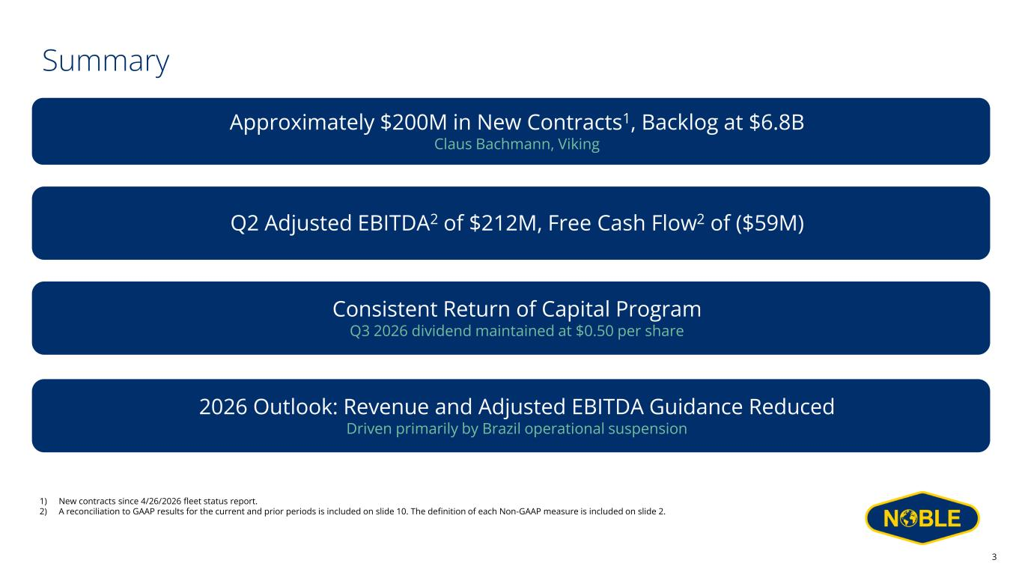
Summary Approximately $200M in New Contracts1, Backlog at $6.8B Claus Bachmann, Viking 2026 Outlook: Revenue and Adjusted EBITDA Guidance Reduced Driven primarily by Brazil operational suspension Q2 Adjusted EBITDA2 of $212M, Free Cash Flow2 of ($59M) 3 Consistent Return of Capital Program Q3 2026 dividend maintained at $0.50 per share 1) New contracts since 4/26/2026 fleet status report. 2) A reconciliation to GAAP results for the current and prior periods is included on slide 10. The definition of each Non-GAAP measure is included on slide 2.

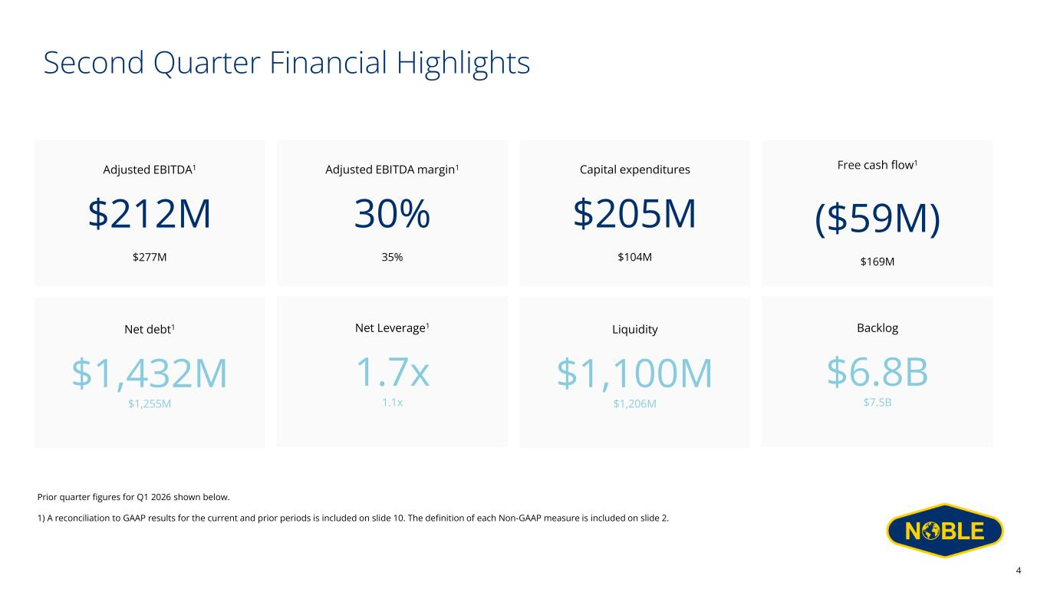
Second Quarter Financial Highlights Adjusted EBITDA1 $212M $277M Capital expenditures $205M $104M Free cash flow1 ($59M) $169M Net debt1 $1,432M $1,255M Backlog $6.8B $7.5B Adjusted EBITDA margin1 30% 35% Net Leverage1 1.7x 1.1x 4 Prior quarter figures for Q1 2026 shown below. 1) A reconciliation to GAAP results for the current and prior periods is included on slide 10. The definition of each Non-GAAP measure is included on slide 2. Liquidity $1,100M $1,206M

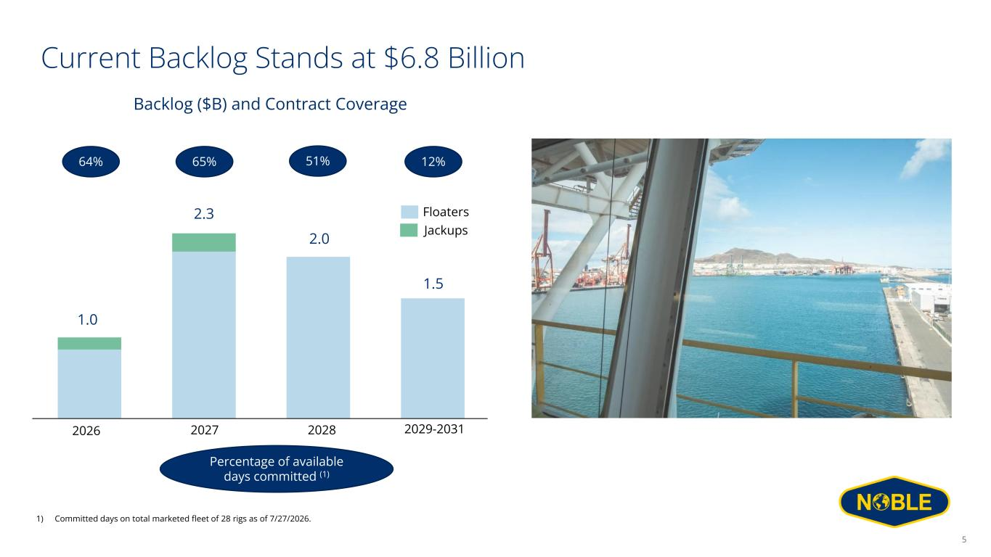
Current Backlog Stands at $6.8 Billion 2026 2027 2028 Floaters Jackups 64% 51%65% Percentage of available days committed (1) Backlog ($B) and Contract Coverage 5 1.0 2.3 2.0 1) Committed days on total marketed fleet of 28 rigs as of 7/27/2026. 2029-2031 1.5 12%

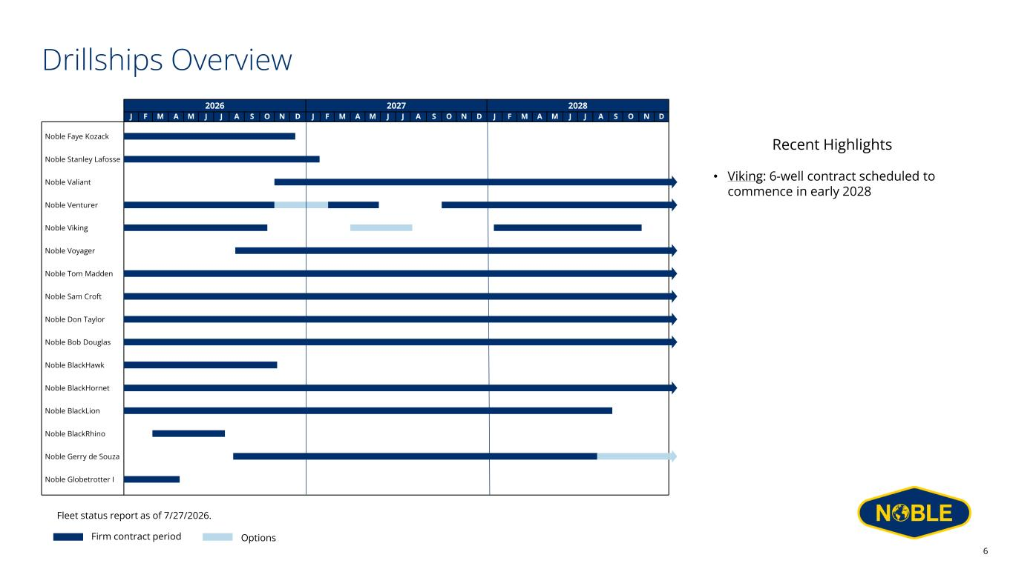
6 Drillships Overview Recent Highlights • Viking: 6-well contract scheduled to commence in early 2028 Firm contract period Options Fleet status report as of 7/27/2026. 2026 2027 2028 J F M A M J J A S O N D J F M A M J J A S O N D J F M A M J J A S O N D Noble Venturer Noble Viking Noble Voyager Noble Tom Madden Noble Sam Croft Noble BlackLion Noble BlackRhino Noble Stanley Lafosse Noble Gerry de Souza Noble Bob Douglas Noble Globetrotter I Noble Faye Kozack Noble Don Taylor Noble Valiant Noble BlackHornet Noble BlackHawk

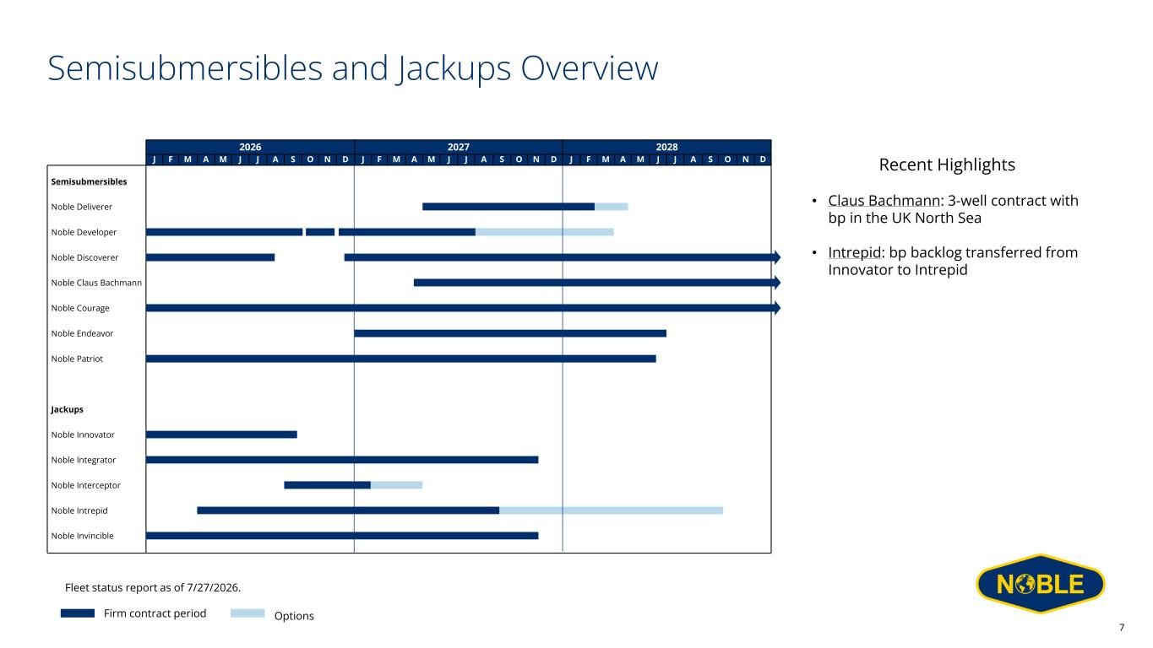
7 Semisubmersibles and Jackups Overview Firm contract period Options Fleet status report as of 7/27/2026. 2026 2027 2028 J F M A M J J A S O N D J F M A M J J A S O N D J F M A M J J A S O N D Semisubmersibles Noble Deliverer Noble Discoverer Noble Claus Bachmann Noble Courage Noble Endeavor Noble Patriot Noble Innovator Noble Integrator Noble Interceptor Noble Intrepid Noble Invincible Noble Developer Jackups Recent Highlights • Claus Bachmann: 3-well contract with bp in the UK North Sea • Intrepid: bp backlog transferred from Innovator to Intrepid

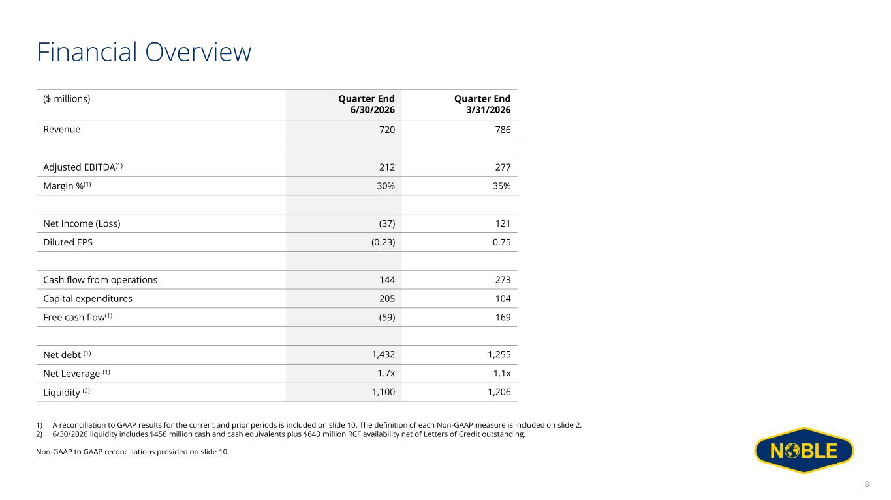
Financial Overview Quarter End 3/31/2026 Quarter End 6/30/2026 ($ millions) 786720Revenue 277212Adjusted EBITDA(1) 35%30%Margin %(1) 121(37)Net Income (Loss) 0.75(0.23)Diluted EPS 273144Cash flow from operations 104205Capital expenditures 169(59)Free cash flow(1) 1,2551,432Net debt (1) 1.1x1.7xNet Leverage (1) 1,2061,100Liquidity (2) 1) A reconciliation to GAAP results for the current and prior periods is included on slide 10. The definition of each Non-GAAP measure is included on slide 2. 2) 6/30/2026 liquidity includes $456 million cash and cash equivalents plus $643 million RCF availability net of Letters of Credit outstanding. Non-GAAP to GAAP reconciliations provided on slide 10. 8

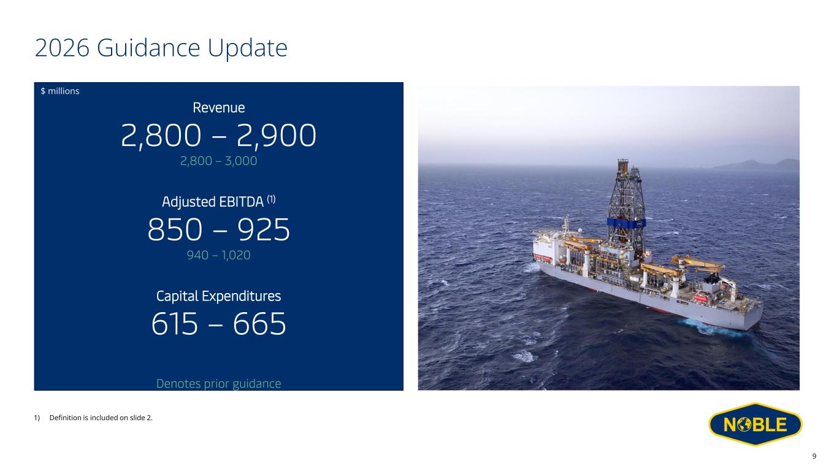
Revenue 2,800 – 2,900 2,800 – 3,000 Adjusted EBITDA (1) 850 – 925 940 – 1,020 Capital Expenditures 615 – 665 2026 Guidance Update $ millions 9 1) Definition is included on slide 2. Denotes prior guidance

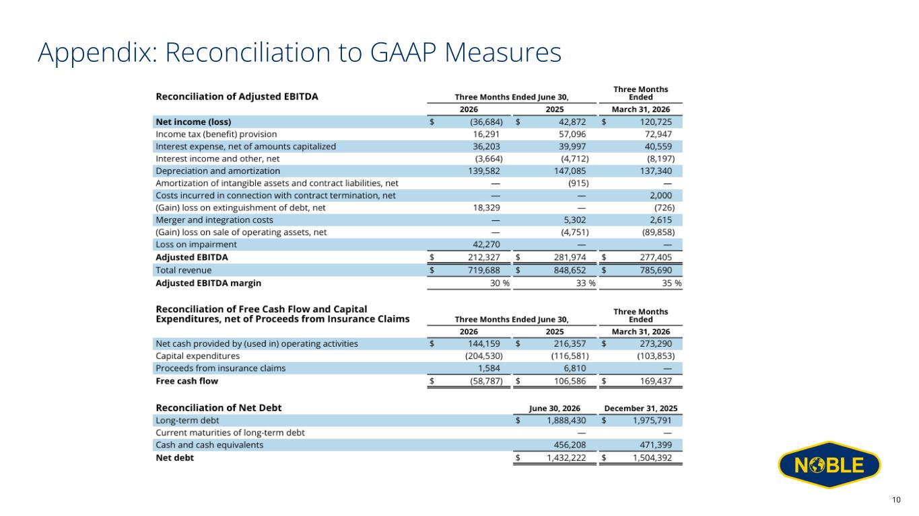
Appendix: Reconciliation to GAAP Measures $ millions 10



