UNITED STATES
SECURITIES AND EXCHANGE COMMISSION
Washington, D.C. 20549
__________________________________________
FORM 8-K
__________________________________________
CURRENT REPORT
Pursuant to Section 13 or 15(d)
of the Securities Exchange Act of 1934
Date of report (date of earliest event reported): August 2, 2023
__________________________________________
NOBLE CORPORATION plc
(Exact name of registrant as specified in its charter)
England and Wales |  |  |  |  |  | 001-41520 |  |  |  |  |  | 98-1644664
(State or other jurisdiction of incorporation) |  |  |  |  |  | (Commission file number) |  |  |  |  |  | (I.R.S. employer identification no.)
13135 Dairy Ashford, |  |  | Suite 800, |  |  | Sugar Land, |  |  | Texas |  |  | 77478
(Address of principal executive offices) |  |  |  |  |  |  |  |  |  |  |  | (Zip code)
Registrant’s telephone number, including area code: 281 276-6100
__________________________________________
Check the appropriate box below if the Form 8-K filing is intended to simultaneously satisfy the filing obligation of the registrant under any of the following provisions
☐ |  |  | Written communications pursuant to Rule 425 under the Securities Act (17 CFR 230.425)
☐ |  |  | Soliciting material pursuant to Rule 14a-12 under the Exchange Act (17 CFR 240.14a-12)
☐ |  |  | Pre-commencement communications pursuant to Rule 14d-2(b) under the Exchange Act (17 CFR 240.14d-2(b))
☐ |  |  | Pre-commencement communications pursuant to Rule 13e-4(c) under the Exchange Act (17 CFR 240.13e-4(c))

Securities registered pursuant to Section 12(b) of the Act:
Title of each class |  |  | Trading Symbol(s) |  |  | Name of each exchange on which registered
A Ordinary Shares, par value $0.00001 per share |  |  | NE |  |  | New York Stock Exchange
Tranche 1 Warrants of Noble Corporation plc |  |  | NE WS |  |  | New York Stock Exchange
Tranche 2 Warrants of Noble Corporation plc |  |  | NE WSA |  |  | New York Stock Exchange
Indicate by check mark whether the registrant is an emerging growth company as defined in Rule 405 of the Securities Act of 1933 (§230.405 of this chapter) or Rule 12b-2 of the Securities Exchange Act of 1934 (§240.12b-2 of this chapter).
Emerging growth company ☐
If an emerging growth company, indicate by check mark if the registrant has elected not to use the extended transition period for complying with any new or revised financial accounting standards provided pursuant to Section 13(a) of the Exchange Act. ☐

Item 2.02. Results of Operations and Financial Condition.
On August 2, 2023, Noble Corporation plc (the “Company”) issued a press release announcing its condensed consolidated financial results for the quarter ended June 30, 2023. A copy of such press release is included as Exhibit 99.1 and will be published in the “Investors” section on the Company’s website at www.noblecorp.com.
Pursuant to the rules and regulations of the Securities and Exchange Commission, the press release is being furnished and shall not be deemed to be “filed” under the Securities Exchange Act of 1934.
Item 7.01. Regulation FD Disclosure.
On August 3, 2023, the President and Chief Executive Officer of Noble Corporation plc (NYSE: NE), Robert W. Eifler, together with other executive officers, plan to announce Noble Corporation plc's earnings for the quarter ended June 30, 2023 via teleconference, which will be open to the public and broadcast live over the internet. A copy of the slide presentation used in connection with the teleconference is attached as Exhibit 99.2 and is incorporated by reference into this item.
Pursuant to the rules and regulations of the Securities and Exchange Commission, the slide presentation is being furnished and shall not be deemed to be “filed” under the Securities Exchange Act of 1934.
Item 9.01. Financial Statements and Exhibits.
 |  |  | (d) Exhibits
EXHIBIT
NUMBER |  |  | DESCRIPTION
Exhibit 99.1 |  |  | Press Release issued by Noble Corporation plc dated August 2, 2023
Exhibit 99.2 |  |  | Noble Corporation plc Slide Presentation dated August 3, 2023
Exhibit 104 |  |  | Cover Page Interactive Data File – the cover page XBRL tags are embedded within the Inline XBRL document.

SIGNATURES

Pursuant to the requirements of the Securities Exchange Act of 1934, the Registrant has duly caused this report to be signed on its behalf by the undersigned hereunto duly authorized.

 |  |  |  |  |  |  |  |  |  |  |  |  |  |  | NOBLE CORPORATION plc
Date: |  |  | August 2, 2023 |  |  |  |  |  |  |  |  |  |  |  | By: |  |  |  |  |  | /s/ Robert W. Eifler
 |  |  |  |  |  |  |  |  |  |  |  |  |  |  |  |  |  |  |  |  | Robert W. Eifler
 |  |  |  |  |  |  |  |  |  |  |  |  |  |  |  |  |  |  |  |  | President and Chief Executive Officer

EXHIBIT 99.1

PRESS RELEASE |  |  |  |  |  | 
NOBLE CORPORATION PLC ANNOUNCES SECOND QUARTER 2023 RESULTS
•Amplifying capital returns to shareholders with $60 million of share repurchases in Q2 and quarterly cash dividend initiated at $0.30 per share.
•Total backlog grows by 9% to $5.0 billion with new contracts totaling $0.8 billion secured over the past three months.
•Q2 Net Income of $66 million, Diluted Earnings Per Share of $0.45, Adjusted EBITDA of $188 million, net cash provided by operating activities of $211 million, and Free Cash Flow of $104 million.

SUGAR LAND, TEXAS, August 2, 2023 - Noble Corporation plc (NYSE: NE, CSE: NOBLE, “Noble”, or the “Company”) today reported second quarter 2023 results.
 |  |  |  |  |  | Three Months Ended
(in millions, except per share amounts) |  |  |  |  |  | June 30, 2023 |  |  |  |  |  | June 30, 2022 |  |  |  |  |  | March 31, 2023
Total Revenue |  |  |  |  |  | $ | 639 |  |  |  |  | $ | 275 |  |  |  |  | $ | 610
Contract Drilling Services Revenue |  |  |  |  |  | 606 |  |  |  |  |  | 262 |  |  |  |  |  | 575
Net Income (Loss) |  |  |  |  |  | 66 |  |  |  |  |  | 37 |  |  |  |  |  | 108
Adjusted EBITDA* |  |  |  |  |  | 188 |  |  |  |  |  | 84 |  |  |  |  |  | 138
Adjusted Net Income (Loss)* |  |  |  |  |  | 56 |  |  |  |  |  | 33 |  |  |  |  |  | 27
Basic Earnings (Loss) Per Share |  |  |  |  |  | 0.48 |  |  |  |  |  | 0.53 |  |  |  |  |  | 0.80
Diluted Earnings (Loss) Per Share |  |  |  |  |  | 0.45 |  |  |  |  |  | 0.45 |  |  |  |  |  | 0.74
Adjusted Diluted Earnings (Loss) Per Share* |  |  |  |  |  | 0.38 |  |  |  |  |  | 0.40 |  |  |  |  |  | 0.19
* A Non-GAAP supporting schedule is included with the statements and schedules attached to this press release.
Robert W. Eifler, President and Chief Executive Officer of Noble Corporation plc, stated “Our second quarter results reflected solid operational and financial performance. Our recent initiation of a quarterly dividend starting at $0.30 per share, combined with $60 million of share repurchases in the second quarter, highlights our industry leading platform for cash flow generation and our commitment to returning capital to shareholders. We are realizing the combined benefits of the business combination with Maersk Drilling with our enhanced capabilities, we believe, allowing us to better serve our customers. Continuing improvement in the UDW market has driven our backlog to $5 billion, with several recent floater awards including the Noble Faye Kozack’s 2.5-year contract in Brazil, and we are increasingly encouraged by the expanding geographic breadth of UDW demand worldwide.”
Second Quarter Results
Contract drilling services revenue for the second quarter of 2023 totaled $606 million compared to $575 million in the first quarter, with the sequential increase driven by improving average dayrates. Marketed fleet utilization was 76% in the three months ended June 30, 2023 compared to 80% in the previous quarter. Contract drilling services costs for the second quarter were $363 million, flat versus the first quarter. Adjusted EBITDA increased to $188 million in the second quarter, up from $138 million in the first quarter. Net cash provided by operating
1
activities in the second quarter was $211 million, capital expenditures were $107 million, and free cash flow (non-GAAP) was $104 million.
Balance Sheet and Capital Allocation
The Company's balance sheet as of June 30, 2023 reflected total debt principal value of $600 million and cash (and cash equivalents) of $255 million. Share repurchases totaled $60 million during the second quarter, bringing 2023 year-to-date share repurchases to $70 million, following approximately $86 million of cash used for share repurchases during the fourth quarter of 2022 (including the mandatory purchase associated with the Maersk Drilling squeeze-out).
Subsequent to the end of the second quarter, Noble announced the initiation of a planned quarterly interim dividend program, beginning with a $0.30 per share dividend to be paid on September 14, 2023 to shareholders of record at close of business on August 17, 2023.
Operating Highlights and Backlog
Noble's marketed fleet of sixteen floaters was 90% contracted through the second quarter, compared with 91% in the prior quarter. All sixteen marketed floaters continue to be consistently contracted with strong visibility for future follow-on opportunities, while utilization remains tempered slightly by gaps between contracts and planned SPS related downtime. Leading edge dayrates for working tier 1 drillships are in the mid to high-$400,000s; 6th generation floaters also continue to command a normal price discount to tier 1 drillships consistent with technical capability differentials.
Subsequent to last quarter’s earnings press release, new contracts for Noble’s floater fleet with total contract value of approximately $750 million (including mobilization payments) include the following:
•Noble Faye Kozack was awarded a 2.5 year contract with Petrobras, expected to commence in Q1 2024 and valued at approximately $500 million including mobilization and additional services.
•Noble Voyager was awarded a one-well contract from Shell for an exploration well in Mauritania at an undisclosed value. This contract follows in direct continuation of the current Shell contract in Colombia and is expected to extend the rig through year-end 2023.
•Noble Discoverer was awarded a one-well contract with Petronas in Suriname, expected to commence in August 2023, with an estimated duration of 90 days. The firm contract value is approximately $43 million, including additional services provided, mobilization and demobilization fees.
•Noble Viking had three option wells exercised by Shell, with total contract value of approximately $49 million and estimated total duration of 111 days. The first of these three option wells is scheduled to commence in December following the rig’s SPS, and the rig’s firm backlog is now extended into Q2 2025.
•Noble Deliverer received a nine-month extension from Inpex in Australia, expected to continue from July 2024 to April 2025 at a dayrate of $451,500.
Utilization of Noble's thirteen marketed jackups was 59% in the second quarter, compared with 67% utilization during the first quarter, with sequential downticks in utilization experienced by the Noble Tom Prosser, Noble Innovator and Noble Interceptor.
Commercial activity for the jackup fleet was subdued in the first half of 2023 but has recently begun to pick up, and we anticipate that jackup fleet utilization will begin improving based on existing and potential contracts. The warm stacked Noble Intrepid has recently been awarded a contract with Harbour Energy for 10 months of accommodation scope in the U.K. North Sea with a total contract value of $28.5 million. Additionally, the Noble Tom Prosser has recently commenced its long term program in Malaysia in July, and we believe the Noble Regina Allen is well positioned to resume operations by mid 2024 upon completion of repairs. Based on these dynamics and additional contract prospects over the near term, a steady recovery in jackup revenue and EBITDA contribution is expected to unfold over the coming quarters, with a more assertive recovery still predicated on demand dynamics in Norway and then North Sea from late 2024 onward.
Noble's backlog as of August 2, 2023 stands at $5.0 billion.
Outlook
For the full year 2023, Noble maintains the previously communicated guidance for total revenue in the range of $2.35 to $2.55 billion, Adjusted EBITDA of $725 to $825 million, and capital expenditures (net of reimbursable capex) between $325 and $365 million.
2
Commenting on Noble’s outlook, Mr. Eifler stated, “Offshore fundamentals remain exceptionally strong, supporting a steady upward progression in contract status across our fleet. We expect UDW market tightness to persist and drive further upward pressure on dayrates going forward. With Adjusted EBITDA and Free Cash Flow expected to increase in the second half of the year versus the first half, we remain focused on maximizing shareholder value through best-in-class execution and returning the significant majority of free cash flow to shareholders.”
Due to the forward-looking nature of Adjusted EBITDA, management cannot reliably predict certain of the necessary components of the most directly comparable forward-looking GAAP measure. Accordingly, the Company is unable to present a quantitative reconciliation of such forward-looking non-GAAP financial measure to the most directly comparable forward-looking GAAP financial measure without unreasonable effort. The unavailable information could have a significant effect on Noble’s full year 2023 GAAP financial results.
Conference Call
Noble will host a conference call related to its second quarter 2023 results on Thursday, August 3rd, 2023, at 8:00 a.m. U.S. Central Time. Interested parties may dial +1 929-203-0901 and refer to conference ID 31391 approximately 15 minutes prior to the scheduled start time. Additionally, a live webcast link will be available on the Investor Relations section of the Company’s website. A webcast replay will be accessible for a limited time following the scheduled call.
For additional information, visit www.noblecorp.com or email investors@noblecorp.com

Contact Noble Corporation plc
Ian Macpherson
Vice President - Investor Relations
+1 713-239-6507
imacpherson@noblecorp.com

About Noble Corporation plc
Noble is a leading offshore drilling contractor for the oil and gas industry. The Company owns and operates one of the most modern, versatile, and technically advanced fleets in the offshore drilling industry. Noble and its predecessors have been engaged in the contract drilling of oil and gas wells since 1921. Noble performs, through its subsidiaries, contract drilling services with a fleet of offshore drilling units focused largely on ultra-deepwater and high specification jackup drilling opportunities in both established and emerging regions worldwide. Additional information on Noble is available at www.noblecorp.com.
Forward-looking Statements
This communication includes “forward-looking statements” within the meaning of Section 27A of the Securities Act and Section 21E of the Exchange Act, as amended. All statements other than statements of historical facts included in this communication are forward looking statements, including those regarding future guidance, including revenue, adjusted EBITDA, the offshore drilling market and demand fundamentals, realization and timing of integration synergies, related costs to achieve, free cash flow expectations, capital expenditure, capital allocation expectations including planned dividend and share repurchases, contract backlog, rig demand, expected future contracts, anticipated contract start dates, dayrates and duration, fleet condition and utilization, 2023 and 2024 financial guidance, business, financial performance and position and our plans, objectives, expectations and intentions related to the Noble-Maersk merger. Forward-looking statements involve risks, uncertainties and assumptions, and actual results may differ materially from any future results expressed or implied by such forward-looking statements. When used in this report, or in the documents incorporated by reference, the words “anticipate,” “believe,” “continue,” “could,” “estimate,” “expect,” “intend,” “may,” “might,” “on track,” “plan,” “possible,” “potential,” “predict,” “project,” “should,” “would,” “shall,” “target,” “will” and similar expressions are intended to be among the statements that identify forward-looking statements. Although we believe that the expectations reflected in such forward-looking statements are reasonable, we cannot assure you that such expectations will prove to be correct. These forward-looking statements speak only as of the date of this communication and we undertake no obligation to revise or update any forward-looking statement for any reason, except as required by law. Risks and uncertainties include, but are not limited to, those detailed in Noble’s most recent Annual Report on Form 10-K, Quarterly Reports Form 10-Q and other filings with the U.S.
3
Securities and Exchange Commission. We cannot control such risk factors and other uncertainties, and in many cases, we cannot predict the risks and uncertainties that could cause our actual results to differ materially from those indicated by the forward-looking statements. You should consider these risks and uncertainties when you are evaluating us. With respect to our capital allocation policy, distributions to shareholders in the form of either dividends or share buybacks are subject to the Board of Directors’ assessment of factors such as business development, growth strategy, current leverage and financing needs. There can be no assurance that a dividend will be declared or continued.

4
NOBLE CORPORATION plc AND SUBSIDIARIES
CONDENSED CONSOLIDATED STATEMENTS OF OPERATIONS
(In thousands, except per share amounts)
(Unaudited)
 |  |  |  |  |  | Three Months Ended June 30, |  |  |  |  |  |  |  |  |  |  |  | Six Months Ended June 30,
 |  |  |  |  |  | 2023 |  |  |  |  |  | 2022 |  |  |  |  |  | 2023 |  |  |  |  |  | 2022
Operating revenues
Contract drilling services |  |  |  |  |  | $ | 606,180 |  |  |  |  | $ | 262,463 |  |  |  |  | $ | 1,181,470 |  |  |  |  | $ | 457,498
Reimbursables and other |  |  |  |  |  | 32,355 |  |  |  |  |  | 12,690 |  |  |  |  |  | 67,119 |  |  |  |  |  | 27,885
 |  |  |  |  |  | 638,535 |  |  |  |  |  | 275,153 |  |  |  |  |  | 1,248,589 |  |  |  |  |  | 485,383
Operating costs and expenses
Contract drilling services |  |  |  |  |  | 362,533 |  |  |  |  |  | 178,145 |  |  |  |  |  | 724,322 |  |  |  |  |  | 344,228
Reimbursables |  |  |  |  |  | 24,796 |  |  |  |  |  | 10,333 |  |  |  |  |  | 50,802 |  |  |  |  |  | 23,811
Depreciation and amortization |  |  |  |  |  | 71,324 |  |  |  |  |  | 26,636 |  |  |  |  |  | 141,266 |  |  |  |  |  | 52,241
General and administrative |  |  |  |  |  | 32,352 |  |  |  |  |  | 16,687 |  |  |  |  |  | 62,389 |  |  |  |  |  | 34,211
Merger and integration costs |  |  |  |  |  | 22,452 |  |  |  |  |  | 9,057 |  |  |  |  |  | 34,083 |  |  |  |  |  | 18,578
(Gain) loss on sale of operating assets, net |  |  |  |  |  | — |  |  |  |  |  | 1,103 |  |  |  |  |  | — |  |  |  |  |  | (3,459)
Hurricane losses and (recoveries), net |  |  |  |  |  | 15,934 |  |  |  |  |  | (14,407) |  |  |  |  |  | 19,478 |  |  |  |  |  | 2,805
 |  |  |  |  |  | 529,391 |  |  |  |  |  | 227,554 |  |  |  |  |  | 1,032,340 |  |  |  |  |  | 472,415
Operating income (loss) |  |  |  |  |  | 109,144 |  |  |  |  |  | 47,599 |  |  |  |  |  | 216,249 |  |  |  |  |  | 12,968
Other income (expense)
Interest expense, net of amounts capitalized |  |  |  |  |  | (14,662) |  |  |  |  |  | (7,715) |  |  |  |  |  | (31,534) |  |  |  |  |  | (15,395)
Gain (loss) on extinguishment of debt, net |  |  |  |  |  | (26,397) |  |  |  |  |  | — |  |  |  |  |  | (26,397) |  |  |  |  |  | —
Interest income and other, net |  |  |  |  |  | (2,940) |  |  |  |  |  | 1,081 |  |  |  |  |  | (914) |  |  |  |  |  | 1,531
Income (loss) before income taxes |  |  |  |  |  | 65,145 |  |  |  |  |  | 40,965 |  |  |  |  |  | 157,404 |  |  |  |  |  | (896)
Income tax benefit (provision) |  |  |  |  |  | 671 |  |  |  |  |  | (3,908) |  |  |  |  |  | 16,475 |  |  |  |  |  | 1,297
Net income (loss) |  |  |  |  |  | $ | 65,816 |  |  |  |  | $ | 37,057 |  |  |  |  | $ | 173,879 |  |  |  |  | $ | 401
Per share data
Basic:
Net income (loss) |  |  |  |  |  | $ | 0.48 |  |  |  |  | $ | 0.53 |  |  |  |  | $ | 1.27 |  |  |  |  | $ | 0.01
Diluted:
Net income (loss) |  |  |  |  |  | $ | 0.45 |  |  |  |  | $ | 0.45 |  |  |  |  | $ | 1.19 |  |  |  |  | $ | —

5
NOBLE CORPORATION plc AND SUBSIDIARIES
CONDENSED CONSOLIDATED BALANCE SHEETS
(In thousands)
(Unaudited)
 |  |  |  |  |  | June 30, 2023 |  |  |  |  |  | December 31, 2022
ASSETS
Current assets
Cash and cash equivalents |  |  |  |  |  | $ | 255,356 |  |  |  |  | $ | 476,206
Accounts receivable, net |  |  |  |  |  | 516,800 |  |  |  |  |  | 468,802
Prepaid expenses and other current assets |  |  |  |  |  | 160,462 |  |  |  |  |  | 106,782
Total current assets |  |  |  |  |  | 932,618 |  |  |  |  |  | 1,051,790
Intangible assets |  |  |  |  |  | 17,018 |  |  |  |  |  | 34,372
Property and equipment, at cost |  |  |  |  |  | 4,329,002 |  |  |  |  |  | 4,163,205
Accumulated depreciation |  |  |  |  |  | (322,444) |  |  |  |  |  | (181,904)
Property and equipment, net |  |  |  |  |  | 4,006,558 |  |  |  |  |  | 3,981,301
Goodwill |  |  |  |  |  | 14,626 |  |  |  |  |  | 26,016
Other assets |  |  |  |  |  | 226,582 |  |  |  |  |  | 141,385
Total assets |  |  |  |  |  | $ | 5,197,402 |  |  |  |  | $ | 5,234,864
LIABILITIES AND EQUITY
Current liabilities
Current maturities of long-term debt |  |  |  |  |  | $ | — |  |  |  |  | $ | 159,715
Accounts payable |  |  |  |  |  | 310,723 |  |  |  |  |  | 290,690
Accrued payroll and related costs |  |  |  |  |  | 77,049 |  |  |  |  |  | 76,185
Other current liabilities |  |  |  |  |  | 126,379 |  |  |  |  |  | 140,508
Total current liabilities |  |  |  |  |  | 514,151 |  |  |  |  |  | 667,098
Long-term debt |  |  |  |  |  | 585,389 |  |  |  |  |  | 513,055
Other liabilities |  |  |  |  |  | 298,650 |  |  |  |  |  | 265,743
Noncurrent contract liabilities |  |  |  |  |  | 79,792 |  |  |  |  |  | 181,883
Total liabilities |  |  |  |  |  | 1,477,982 |  |  |  |  |  | 1,627,779
Commitments and contingencies
Total shareholders’ equity |  |  |  |  |  | 3,719,420 |  |  |  |  |  | 3,607,085
Total liabilities and equity |  |  |  |  |  | $ | 5,197,402 |  |  |  |  | $ | 5,234,864

6
NOBLE CORPORATION plc AND SUBSIDIARIES
CONDENSED CONSOLIDATED STATEMENTS OF CASH FLOWS
(In thousands)
(Unaudited)
 |  |  | Six Months Ended June 30,
 |  |  | 2023 |  |  |  |  |  | 2022
Cash flows from operating activities
Net income (loss) |  |  | $ | 173,879 |  |  |  |  | $ | 401
Adjustments to reconcile net income (loss) to net cash flow from operating activities:
Depreciation and amortization |  |  | 141,266 |  |  |  |  |  | 52,241
Amortization of intangible assets and contract liabilities, net |  |  | (84,737) |  |  |  |  |  | 28,354
(Gain) loss on extinguishment of debt, net |  |  | 26,397 |  |  |  |  |  | —
(Gain) loss on sale of operating assets, net |  |  | — |  |  |  |  |  | (6,767)
Changes in components of working capital
Change in taxes receivable |  |  | (20,284) |  |  |  |  |  | (345)
Net changes in other operating assets and liabilities |  |  | (88,441) |  |  |  |  |  | (37,585)
Net cash provided by (used in) operating activities |  |  | 148,080 |  |  |  |  |  | 36,299
Cash flows from investing activities
Capital expenditures |  |  | (169,530) |  |  |  |  |  | (79,525)
Proceeds from disposal of assets, net |  |  | — |  |  |  |  |  | 15,756
Net cash provided by (used in) investing activities |  |  | (169,530) |  |  |  |  |  | (63,769)
Cash flows from financing activities
Issuance of senior notes |  |  | 600,000 |  |  |  |  |  | —
Repayments of debt |  |  | (673,411) |  |  |  |  |  | —
Debt extinguishment costs |  |  | (25,697) |  |  |  |  |  | —
Debt issuance costs |  |  | (24,914) |  |  |  |  |  | —
Share repurchases |  |  | (70,000) |  |  |  |  |  | —
Other financing activities |  |  | (8,253) |  |  |  |  |  | (4,486)
Net cash provided by (used in) financing activities |  |  | (202,275) |  |  |  |  |  | (4,486)
Net increase (decrease) in cash, cash equivalents and restricted cash |  |  | (223,725) |  |  |  |  |  | (31,956)
Cash, cash equivalents and restricted cash, beginning of period |  |  | 485,707 |  |  |  |  |  | 196,722
Cash, cash equivalents and restricted cash, end of period |  |  | $ | 261,982 |  |  |  |  | $ | 164,766

7
NOBLE CORPORATION plc AND SUBSIDIARIES
OPERATIONAL INFORMATION
(Unaudited)
 |  |  | Average Rig Utilization
 |  |  | Three Months Ended |  |  |  |  |  | Three Months Ended |  |  |  |  |  | Three Months Ended
 |  |  | June 30, 2023 |  |  |  |  |  | March 31, 2023 |  |  |  |  |  | June 30, 2022
Floaters |  |  | 76 |  | % |  |  |  | 77 |  | % |  |  |  | 81 |  | %
Jackups |  |  | 62 |  | % |  |  |  | 70 |  | % |  |  |  | 68 |  | %
Total |  |  | 70 |  | % |  |  |  | 74 |  | % |  |  |  | 76 |  | %
 |  |  | Operating Days
 |  |  | Three Months Ended |  |  |  |  |  | Three Months Ended |  |  |  |  |  | Three Months Ended
 |  |  | June 30, 2023 |  |  |  |  |  | March 31, 2023 |  |  |  |  |  | June 30, 2022
Floaters |  |  | 1,305 |  |  |  |  |  | 1,314 |  |  |  |  |  | 813
Jackups |  |  | 786 |  |  |  |  |  | 877 |  |  |  |  |  | 495
Total |  |  | 2,091 |  |  |  |  |  | 2,191 |  |  |  |  |  | 1,308
 |  |  | Average Dayrates
 |  |  | Three Months Ended |  |  |  |  |  | Three Months Ended |  |  |  |  |  | Three Months Ended
 |  |  | June 30, 2023 |  |  |  |  |  | March 31, 2023 |  |  |  |  |  | June 30, 2022
Floaters |  |  | $ | 363,167 |  |  |  |  | $ | 331,705 |  |  |  |  | $ | 266,887
Jackups |  |  | 128,885 |  |  |  |  |  | 97,940 |  |  |  |  |  | 120,824
Total |  |  | $ | 275,066 |  |  |  |  | $ | 238,130 |  |  |  |  | $ | 211,626

8
NOBLE CORPORATION plc AND SUBSIDIARIES
CALCULATION OF BASIC AND DILUTED NET INCOME/(LOSS) PER SHARE
(In thousands, except per share amounts)
(Unaudited)

The following tables presents the computation of basic and diluted income (loss) per share:
 |  |  |  |  |  | Three Months Ended June 30, |  |  |  |  |  |  |  |  |  |  |  | Six Months Ended June 30,
 |  |  |  |  |  | 2023 |  |  |  |  |  | 2022 |  |  |  |  |  | 2023 |  |  |  |  |  | 2022
Numerator:
Net income (loss) |  |  |  |  |  | $ | 65,816 |  |  |  |  | $ | 37,057 |  |  |  |  | $ | 173,879 |  |  |  |  | $ | 401
Denominator:
Weighted average shares outstanding - basic |  |  |  |  |  | 138,058 |  |  |  |  |  | 69,789 |  |  |  |  |  | 136,502 |  |  |  |  |  | 68,722
Dilutive effect of share-based awards |  |  |  |  |  | 3,242 |  |  |  |  |  | 3,378 |  |  |  |  |  | 3,242 |  |  |  |  |  | 3,378
Dilutive effect of warrants |  |  |  |  |  | 5,692 |  |  |  |  |  | 9,535 |  |  |  |  |  | 6,810 |  |  |  |  |  | 9,185
Weighted average shares outstanding - diluted |  |  |  |  |  | 146,992 |  |  |  |  |  | 82,702 |  |  |  |  |  | 146,554 |  |  |  |  |  | 81,285
Per share data
Basic:
Net income (loss) |  |  |  |  |  | $ | 0.48 |  |  |  |  | $ | 0.53 |  |  |  |  | $ | 1.27 |  |  |  |  | $ | 0.01
Diluted:
Net income (loss) |  |  |  |  |  | $ | 0.45 |  |  |  |  | $ | 0.45 |  |  |  |  | $ | 1.19 |  |  |  |  | $ | —

9
NOBLE CORPORATION plc AND SUBSIDIARIES
NON-GAAP MEASURES AND RECONCILIATION

Certain non-GAAP measures and corresponding reconciliations to GAAP financial measures for the Company have been provided for meaningful comparisons between current results and prior operating periods. Generally, a non-GAAP financial measure is a numerical measure of a company’s performance, financial position, or cash flows that excludes or includes amounts that are not normally included or excluded in the most directly comparable measure calculated and presented in accordance with generally accepted accounting principles.
The Company defines “Adjusted EBITDA” as net income (loss) adjusted for interest expense, net of amounts capitalized; interest income and other, net; income tax benefit (provision); and depreciation and amortization expense, as well as, if applicable, gain (loss) on extinguishment of debt, net; losses on economic impairments; restructuring and similar charges; costs related to mergers and integrations; and certain other infrequent operational events. We believe that the Adjusted EBITDA measure provides greater transparency of our core operating performance. We prepare Adjusted Net Income (Loss) by eliminating from Net Income (Loss) the impact of a number of non-recurring items we do not consider indicative of our on-going performance. We prepare Adjusted Diluted Earnings (Loss) per Share by eliminating from Diluted Earnings per Share the impact of a number of non-recurring items we do not consider indicative of our on-going performance. Similar to Adjusted EBITDA, we believe these measures help identify underlying trends that could otherwise be masked by the effect of the non-recurring items we exclude in the measure.
In order to fully assess the financial operating results, management believes that the results of operations, adjusted to exclude the following items, which are included in the Company’s press release issued on August 2, 2023, are appropriate measures of the continuing and normal operations of the Company:
(i)In the second quarters of 2023 and 2022, merger and integration costs; hurricane losses and (recoveries), net; intangible contract amortization and discrete tax items.
(ii)The second quarter of 2023 included a loss on extinguishment of debt, net.
(iii)In addition, the second quarter of 2022 included (gain) loss on sale of operating assets, net and professional services costs related to corporate initiatives.
The Company also discloses free cash flow as a non-GAAP liquidity measure. Free cash flow is calculated as Net cash provided by (used in) operating activities less cash paid for capital expenditures. We believe Free Cash Flow is useful to investors because it measures our ability to generate or use cash. Once business needs and obligations are met, this cash can be used to reinvest in the company for future growth or to return to shareholders through dividend payments or share repurchases.
We believe that these non-GAAP financial measures provide useful information about our financial performance, enhance the overall understanding of our past performance and future prospects, and allow for greater transparency with respect to key metrics used by our management team for financial and operational decision-making. We are presenting these non-GAAP financial measures to assist investors in seeing our financial performance through the eyes of management, and because we believe that these measures provide an additional tool for investors to use in comparing our core financial performance over multiple periods with other companies in our industry.
These non-GAAP adjusted measures should be considered in addition to, and not as a substitute for, or superior to, contract drilling revenue, contract drilling cost, contract drilling margin, average daily revenue, operating income, cash flows from operations, or other measures of financial performance prepared in accordance with GAAP. Please see the following non-GAAP Financial Measures and Reconciliations for a complete description of the adjustments.

10
NOBLE CORPORATION plc AND SUBSIDIARIES
NON-GAAP MEASURES
(In thousands, except per share amounts)
(Unaudited)
Reconciliation of Adjusted EBITDA
 |  |  |  |  |  | Three Months Ended June 30, |  |  |  |  |  |  |  |  |  |  |  | Three Months Ended
 |  |  |  |  |  | 2023 |  |  |  |  |  | 2022 |  |  |  |  |  | March 31, 2023
Net income (loss) |  |  |  |  |  | $ | 65,816 |  |  |  |  | $ | 37,057 |  |  |  |  | $ | 108,063
Income tax (benefit) provision |  |  |  |  |  | (671) |  |  |  |  |  | 3,908 |  |  |  |  |  | (15,804)
Interest expense, net of amounts capitalized |  |  |  |  |  | 14,662 |  |  |  |  |  | 7,715 |  |  |  |  |  | 16,872
Interest income and other, net |  |  |  |  |  | 2,940 |  |  |  |  |  | (1,081) |  |  |  |  |  | (2,026)
Depreciation and amortization |  |  |  |  |  | 71,324 |  |  |  |  |  | 26,636 |  |  |  |  |  | 69,942
Amortization of intangible assets and contract liabilities, net |  |  |  |  |  | (31,009) |  |  |  |  |  | 14,256 |  |  |  |  |  | (53,728)
(Gain) loss on extinguishment of debt, net |  |  |  |  |  | 26,397 |  |  |  |  |  | — |  |  |  |  |  | —
Professional services - corporate projects |  |  |  |  |  | — |  |  |  |  |  | 145 |  |  |  |  |  | —
Merger and integration costs |  |  |  |  |  | 22,452 |  |  |  |  |  | 9,057 |  |  |  |  |  | 11,631
(Gain) loss on sale of operating assets, net |  |  |  |  |  | — |  |  |  |  |  | 1,103 |  |  |  |  |  | —
Hurricane losses and (recoveries), net |  |  |  |  |  | 15,934 |  |  |  |  |  | (14,407) |  |  |  |  |  | 3,544
Adjusted EBITDA |  |  |  |  |  | $ | 187,845 |  |  |  |  | $ | 84,389 |  |  |  |  | $ | 138,494

Reconciliation of Income Tax (Provision) Benefit
 |  |  |  |  |  | Three Months Ended June 30, |  |  |  |  |  |  |  |  |  |  |  | Three Months Ended
 |  |  |  |  |  | 2023 |  |  |  |  |  | 2022 |  |  |  |  |  | March 31, 2023
Income tax benefit (provision) |  |  |  |  |  | $ | 671 |  |  |  |  | $ | (3,908) |  |  |  |  | $ | 15,804
Adjustments
Amortization of intangible assets and contract liabilities, net |  |  |  |  |  | 3,747 |  |  |  |  |  | (2,994) |  |  |  |  |  | 3,501
Hurricane losses and (recoveries), net |  |  |  |  |  | — |  |  |  |  |  | (164) |  |  |  |  |  | —
Discrete tax items |  |  |  |  |  | (47,601) |  |  |  |  |  | (11,105) |  |  |  |  |  | (45,631)
Total Adjustments |  |  |  |  |  | (43,854) |  |  |  |  |  | (14,263) |  |  |  |  |  | (42,130)
Adjusted income tax benefit (provision) |  |  |  |  |  | $ | (43,183) |  |  |  |  | $ | (18,171) |  |  |  |  | $ | (26,326)
11
NOBLE CORPORATION plc AND SUBSIDIARIES
NON-GAAP RECONCILIATION
(In thousands, except per share amounts)
(Unaudited)
Reconciliation of Net Income (Loss)
 |  |  |  |  |  | Three Months Ended June 30, |  |  |  |  |  |  |  |  |  |  |  | Three Months Ended
 |  |  |  |  |  | 2023 |  |  |  |  |  | 2022 |  |  |  |  |  | March 31, 2023
Net income (loss) |  |  |  |  |  | $ | 65,816 |  |  |  |  | $ | 37,057 |  |  |  |  | $ | 108,063
Adjustments
Amortization of intangible assets and contract liabilities, net |  |  |  |  |  | (27,262) |  |  |  |  |  | 11,262 |  |  |  |  |  | (50,227)
Professional services - corporate projects |  |  |  |  |  | — |  |  |  |  |  | 145 |  |  |  |  |  | —
Merger and integration costs |  |  |  |  |  | 22,452 |  |  |  |  |  | 9,057 |  |  |  |  |  | 11,631
(Gain) loss on sale of operating assets, net |  |  |  |  |  | — |  |  |  |  |  | 1,103 |  |  |  |  |  | —
Hurricane losses and (recoveries), net |  |  |  |  |  | 15,934 |  |  |  |  |  | (14,571) |  |  |  |  |  | 3,544
(Gain) loss on extinguishment of debt, net |  |  |  |  |  | 26,397 |  |  |  |  |  | — |  |  |  |  |  | —
Discrete tax items |  |  |  |  |  | (47,601) |  |  |  |  |  | (11,105) |  |  |  |  |  | (45,631)
Total Adjustments |  |  |  |  |  | (10,080) |  |  |  |  |  | (4,109) |  |  |  |  |  | (80,683)
Adjusted net income (loss) |  |  |  |  |  | $ | 55,736 |  |  |  |  | $ | 32,948 |  |  |  |  | $ | 27,380
Reconciliation of Diluted EPS
 |  |  |  |  |  | Three Months Ended June 30, |  |  |  |  |  |  |  |  |  |  |  | Three Months Ended
 |  |  |  |  |  | 2023 |  |  |  |  |  | 2022 |  |  |  |  |  | March 31, 2023
Unadjusted diluted EPS |  |  |  |  |  | $ | 0.45 |  |  |  |  | $ | 0.45 |  |  |  |  | $ | 0.74
Adjustments
Amortization of intangible assets and contract liabilities, net |  |  |  |  |  | (0.19) |  |  |  |  |  | 0.14 |  |  |  |  |  | (0.34)
Professional services - corporate projects |  |  |  |  |  | — |  |  |  |  |  | — |  |  |  |  |  | —
Merger and integration costs |  |  |  |  |  | 0.15 |  |  |  |  |  | 0.11 |  |  |  |  |  | 0.08
(Gain) loss on sale of operating assets, net |  |  |  |  |  | — |  |  |  |  |  | 0.01 |  |  |  |  |  | —
Hurricane losses and (recoveries), net |  |  |  |  |  | 0.11 |  |  |  |  |  | (0.18) |  |  |  |  |  | 0.02
(Gain) loss on extinguishment of debt, net |  |  |  |  |  | 0.18 |  |  |  |  |  | — |  |  |  |  |  | —
Discrete tax items |  |  |  |  |  | (0.32) |  |  |  |  |  | (0.13) |  |  |  |  |  | (0.31)
Total Adjustments |  |  |  |  |  | (0.07) |  |  |  |  |  | (0.05) |  |  |  |  |  | (0.55)
Adjusted diluted EPS |  |  |  |  |  | $ | 0.38 |  |  |  |  | $ | 0.40 |  |  |  |  | $ | 0.19
Reconciliation of Free Cash Flow
 |  |  |  |  |  | Three Months Ended June 30, |  |  |  |  |  |  |  |  |  |  |  | Three Months Ended
 |  |  |  |  |  | 2023 |  |  |  |  |  | 2022 |  |  |  |  |  | March 31, 2023
Net cash provided by (used in) operating activities |  |  |  |  |  | $ | 211,160 |  |  |  |  | $ | 88,112 |  |  |  |  | $ | (63,080)
Capital expenditures |  |  |  |  |  | (106,796) |  |  |  |  |  | (32,480) |  |  |  |  |  | (62,734)
Free cash flow |  |  |  |  |  | $ | 104,364 |  |  |  |  | $ | 55,632 |  |  |  |  | $ | (125,814)

12
Noble Corporation plc Second Quarter 2023 Earnings Conference Call August 3rd, 2023

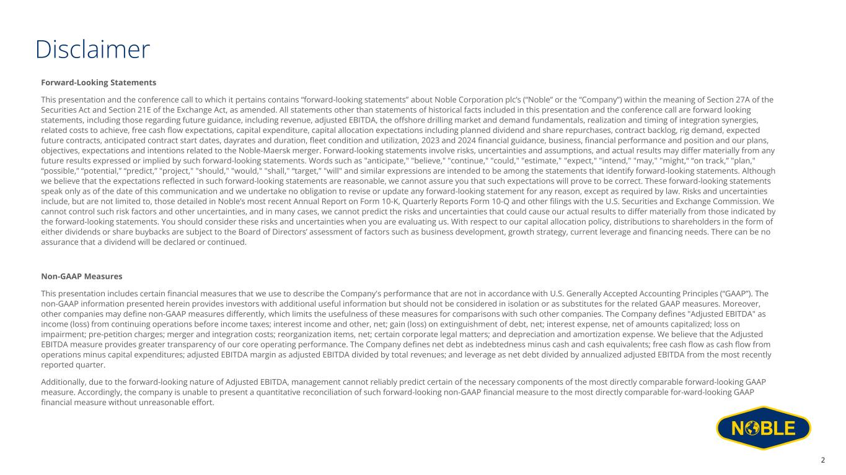
Disclaimer Forward-Looking Statements This presentation and the conference call to which it pertains contains “forward-looking statements” about Noble Corporation plc’s (“Noble” or the “Company”) within the meaning of Section 27A of the Securities Act and Section 21E of the Exchange Act, as amended. All statements other than statements of historical facts included in this presentation and the conference call are forward looking statements, including those regarding future guidance, including revenue, adjusted EBITDA, the offshore drilling market and demand fundamentals, realization and timing of integration synergies, related costs to achieve, free cash flow expectations, capital expenditure, capital allocation expectations including planned dividend and share repurchases, contract backlog, rig demand, expected future contracts, anticipated contract start dates, dayrates and duration, fleet condition and utilization, 2023 and 2024 financial guidance, business, financial performance and position and our plans, objectives, expectations and intentions related to the Noble-Maersk merger. Forward-looking statements involve risks, uncertainties and assumptions, and actual results may differ materially from any future results expressed or implied by such forward-looking statements. Words such as "anticipate," "believe," "continue," "could," "estimate," "expect," "intend," "may," "might,“ “on track,” "plan," “possible,” “potential,” “predict,” "project," "should," "would," "shall," “target,” "will" and similar expressions are intended to be among the statements that identify forward-looking statements. Although we believe that the expectations reflected in such forward-looking statements are reasonable, we cannot assure you that such expectations will prove to be correct. These forward-looking statements speak only as of the date of this communication and we undertake no obligation to revise or update any forward-looking statement for any reason, except as required by law. Risks and uncertainties include, but are not limited to, those detailed in Noble’s most recent Annual Report on Form 10-K, Quarterly Reports Form 10-Q and other filings with the U.S. Securities and Exchange Commission. We cannot control such risk factors and other uncertainties, and in many cases, we cannot predict the risks and uncertainties that could cause our actual results to differ materially from those indicated by the forward-looking statements. You should consider these risks and uncertainties when you are evaluating us. With respect to our capital allocation policy, distributions to shareholders in the form of either dividends or share buybacks are subject to the Board of Directors’ assessment of factors such as business development, growth strategy, current leverage and financing needs. There can be no assurance that a dividend will be declared or continued. Non-GAAP Measures This presentation includes certain financial measures that we use to describe the Company's performance that are not in accordance with U.S. Generally Accepted Accounting Principles (“GAAP”). The non-GAAP information presented herein provides investors with additional useful information but should not be considered in isolation or as substitutes for the related GAAP measures. Moreover, other companies may define non-GAAP measures differently, which limits the usefulness of these measures for comparisons with such other companies. The Company defines "Adjusted EBITDA" as income (loss) from continuing operations before income taxes; interest income and other, net; gain (loss) on extinguishment of debt, net; interest expense, net of amounts capitalized; loss on impairment; pre-petition charges; merger and integration costs; reorganization items, net; certain corporate legal matters; and depreciation and amortization expense. We believe that the Adjusted EBITDA measure provides greater transparency of our core operating performance. The Company defines net debt as indebtedness minus cash and cash equivalents; free cash flow as cash flow from operations minus capital expenditures; adjusted EBITDA margin as adjusted EBITDA divided by total revenues; and leverage as net debt divided by annualized adjusted EBITDA from the most recently reported quarter. Additionally, due to the forward-looking nature of Adjusted EBITDA, management cannot reliably predict certain of the necessary components of the most directly comparable forward-looking GAAP measure. Accordingly, the company is unable to present a quantitative reconciliation of such forward-looking non-GAAP financial measure to the most directly comparable for-ward-looking GAAP financial measure without unreasonable effort. 2

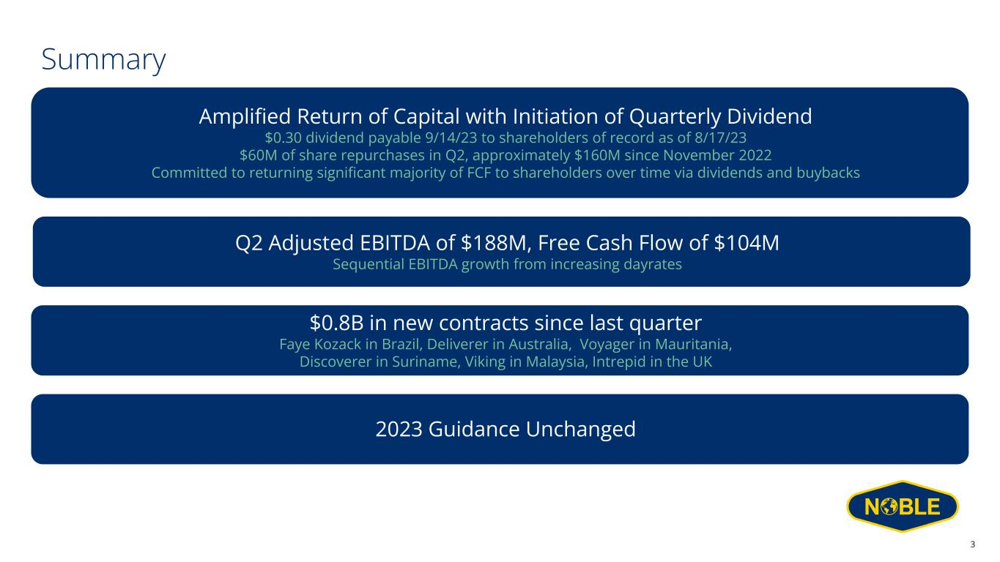
Summary Q2 Adjusted EBITDA of $188M, Free Cash Flow of $104M Sequential EBITDA growth from increasing dayrates $0.8B in new contracts since last quarter Faye Kozack in Brazil, Deliverer in Australia, Voyager in Mauritania, Discoverer in Suriname, Viking in Malaysia, Intrepid in the UK 2023 Guidance Unchanged Amplified Return of Capital with Initiation of Quarterly Dividend $0.30 dividend payable 9/14/23 to shareholders of record as of 8/17/23 $60M of share repurchases in Q2, approximately $160M since November 2022 Committed to returning significant majority of FCF to shareholders over time via dividends and buybacks 3

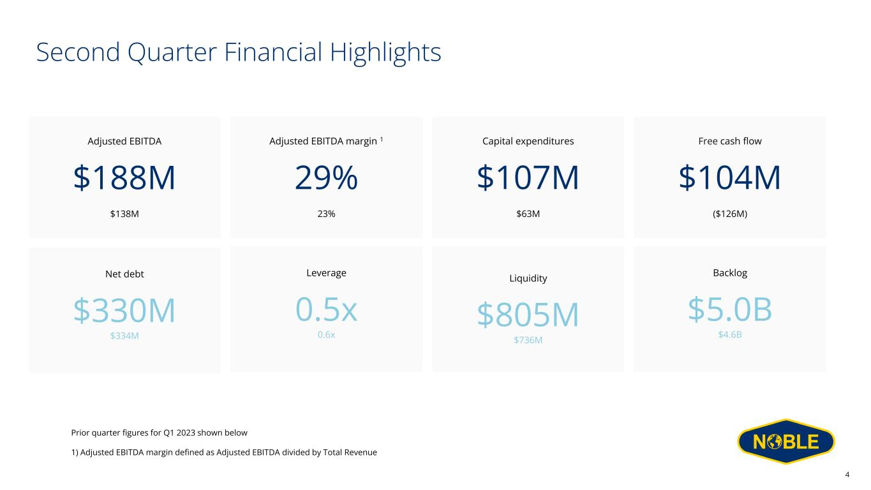
Second Quarter Financial Highlights Adjusted EBITDA $188M $138M Capital expenditures $107M $63M Free cash flow $104M ($126M) Net debt $330M $334M Backlog $5.0B $4.6B Liquidity $805M $736M Adjusted EBITDA margin 1 29% 23% Leverage 0.5x 0.6x 4 Prior quarter figures for Q1 2023 shown below 1) Adjusted EBITDA margin defined as Adjusted EBITDA divided by Total Revenue

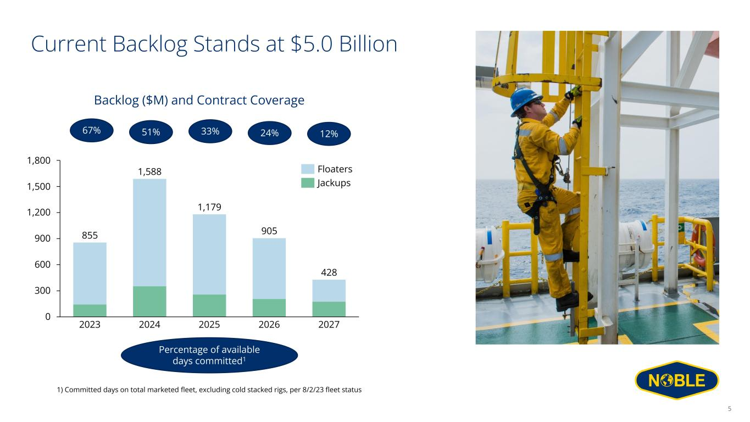
Current Backlog Stands at $5.0 Billion 600 0 1,500 300 900 1,200 1,800 1,588 2023 2024 2025 2026 2027 855 1,179 905 428 Floaters Jackups 67% 51% 24% 12%33% Percentage of available days committed1 Backlog ($M) and Contract Coverage 1) Committed days on total marketed fleet, excluding cold stacked rigs, per 8/2/23 fleet status 5

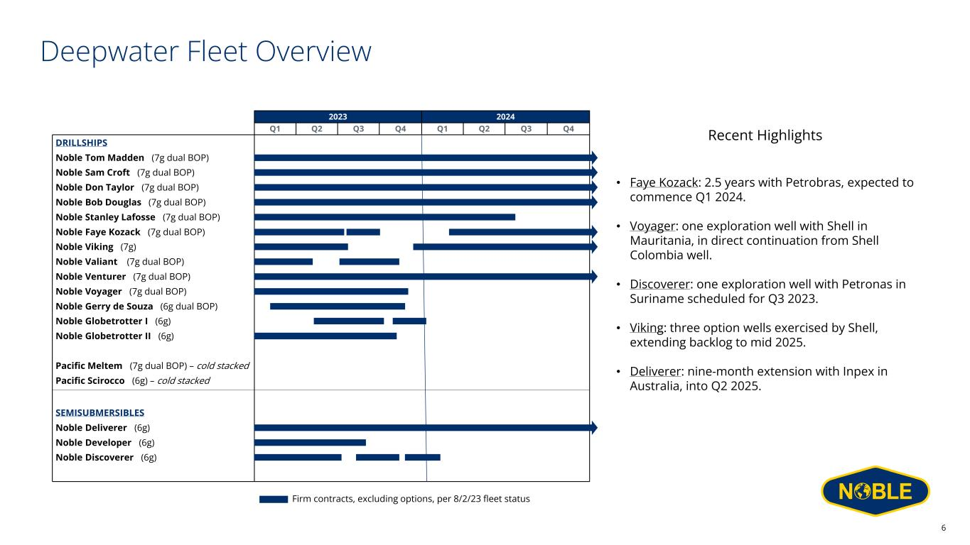
Deepwater Fleet Overview 2023 2024 Q1 Q2 Q3 Q4 Q1 Q2 Q3 Q4 Noble Bob Douglas (7g dual BOP) Noble Globetrotter I (6g) DRILLSHIPS Noble Don Taylor (7g dual BOP) Noble Sam Croft (7g dual BOP) Noble Venturer (7g dual BOP) Noble Viking (7g) Noble Tom Madden (7g dual BOP) Noble Stanley Lafosse (7g dual BOP) Noble Valiant (7g dual BOP) Noble Deliverer (6g) Pacific Meltem (7g dual BOP) – cold stacked Noble Faye Kozack (7g dual BOP) SEMISUBMERSIBLES Pacific Scirocco (6g) – cold stacked Noble Developer (6g) Noble Discoverer (6g) Noble Globetrotter II (6g) Noble Gerry de Souza (6g dual BOP) Noble Voyager (7g dual BOP) Firm contracts, excluding options, per 8/2/23 fleet status Recent Highlights • Faye Kozack: 2.5 years with Petrobras, expected to commence Q1 2024. • Voyager: one exploration well with Shell in Mauritania, in direct continuation from Shell Colombia well. • Discoverer: one exploration well with Petronas in Suriname scheduled for Q3 2023. • Viking: three option wells exercised by Shell, extending backlog to mid 2025. • Deliverer: nine-month extension with Inpex in Australia, into Q2 2025. 6

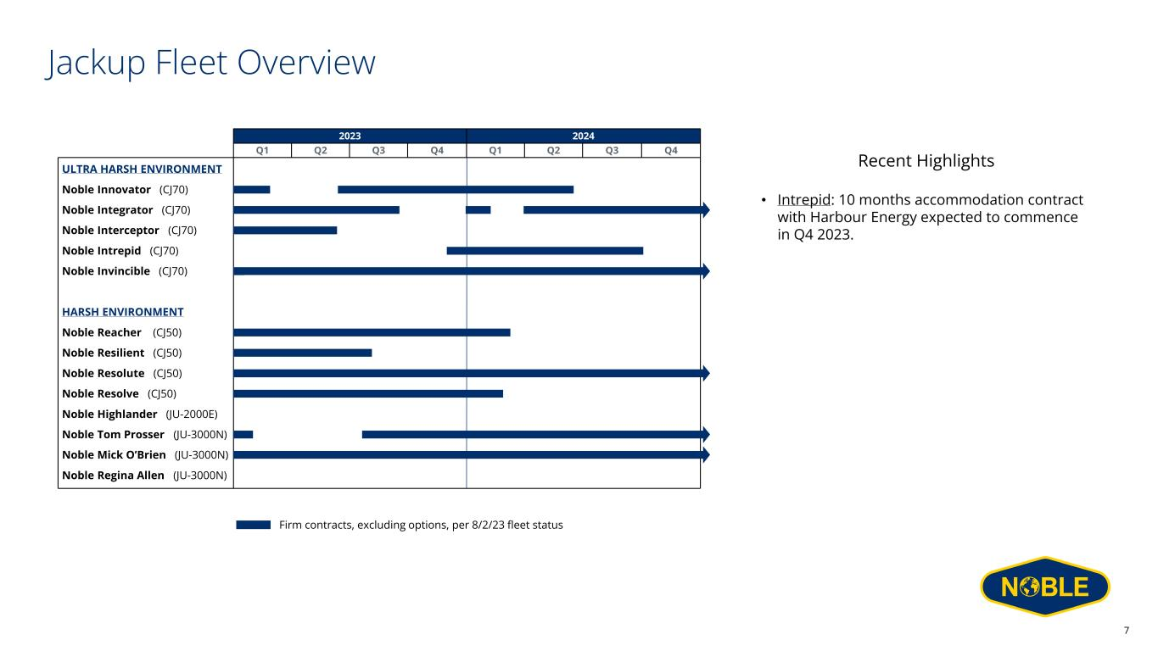
Jackup Fleet Overview 2023 2024 Q1 Q2 Q3 Q4 Q1 Q2 Q3 Q4 Noble Reacher (CJ50) Noble Integrator (CJ70) Noble Resolute (CJ50) Noble Resolve (CJ50) Noble Interceptor (CJ70) Noble Tom Prosser (JU-3000N) Noble Intrepid (CJ70) Noble Mick O’Brien (JU-3000N) ULTRA HARSH ENVIRONMENT Noble Resilient (CJ50) Noble Innovator (CJ70) HARSH ENVIRONMENT Noble Regina Allen (JU-3000N) Noble Invincible (CJ70) Noble Highlander (JU-2000E) Firm contracts, excluding options, per 8/2/23 fleet status Recent Highlights • Intrepid: 10 months accommodation contract with Harbour Energy expected to commence in Q4 2023. 7

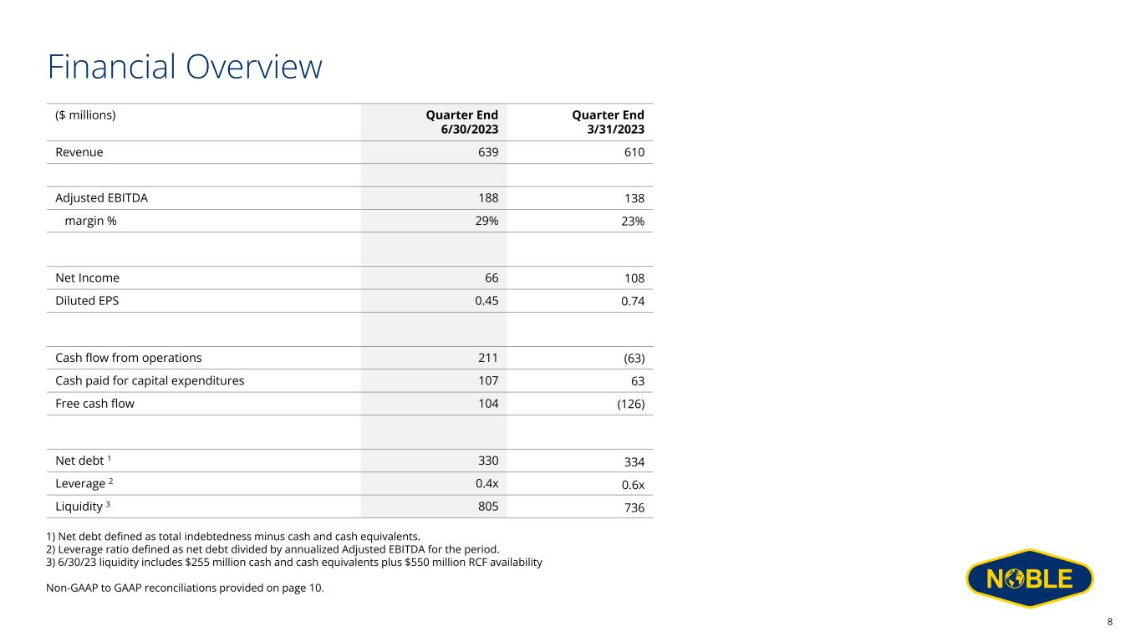
Financial Overview ($ millions) Quarter End 6/30/2023 Quarter End 3/31/2023 Revenue 639 610 Adjusted EBITDA 188 138 margin % 29% 23% Net Income 66 108 Diluted EPS 0.45 0.74 Cash flow from operations 211 (63) Cash paid for capital expenditures 107 63 Free cash flow 104 (126) Net debt 1 330 334 Leverage 2 0.4x 0.6x Liquidity 3 805 736 1) Net debt defined as total indebtedness minus cash and cash equivalents. 2) Leverage ratio defined as net debt divided by annualized Adjusted EBITDA for the period. 3) 6/30/23 liquidity includes $255 million cash and cash equivalents plus $550 million RCF availability Non-GAAP to GAAP reconciliations provided on page 10. 8

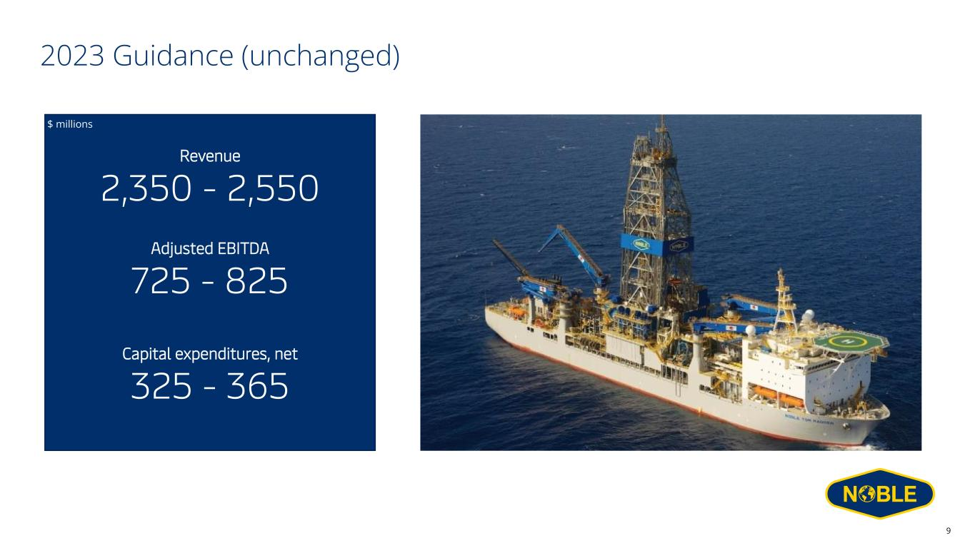
2023 Guidance (unchanged) Revenue 2,350 - 2,550 Adjusted EBITDA 725 - 825 Capital expenditures, net 325 - 365 $ millions 9

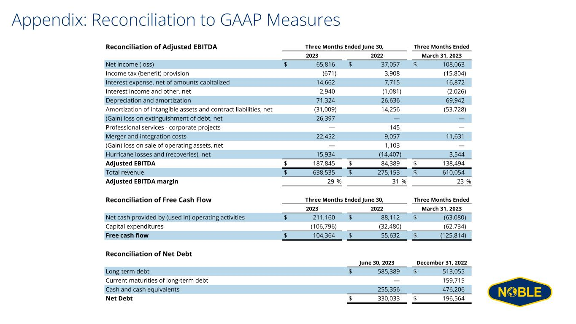
Appendix: Reconciliation to GAAP Measures Reconciliation of Adjusted EBITDA Three Months Ended June 30, Three Months Ended 2023 2022 March 31, 2023 Net income (loss) $ 65,816 $ 37,057 $ 108,063 Income tax (benefit) provision (671) 3,908 (15,804) Interest expense, net of amounts capitalized 14,662 7,715 16,872 Interest income and other, net 2,940 (1,081) (2,026) Depreciation and amortization 71,324 26,636 69,942 Amortization of intangible assets and contract liabilities, net (31,009) 14,256 (53,728) (Gain) loss on extinguishment of debt, net 26,397 — — Professional services - corporate projects — 145 — Merger and integration costs 22,452 9,057 11,631 (Gain) loss on sale of operating assets, net — 1,103 — Hurricane losses and (recoveries), net 15,934 (14,407) 3,544 Adjusted EBITDA $ 187,845 $ 84,389 $ 138,494 Total revenue $ 638,535 $ 275,153 $ 610,054 Adjusted EBITDA margin 29 % 31 % 23 % Reconciliation of Free Cash Flow Three Months Ended June 30, Three Months Ended 2023 2022 March 31, 2023 Net cash provided by (used in) operating activities $ 211,160 $ 88,112 $ (63,080) Capital expenditures (106,796) (32,480) (62,734) Free cash flow $ 104,364 $ 55,632 $ (125,814) Reconciliation of Net Debt June 30, 2023 December 31, 2022 Long-term debt $ 585,389 $ 513,055 Current maturities of long-term debt — 159,715 Cash and cash equivalents 255,356 476,206 Net Debt $ 330,033 $ 196,564



